**D-G**

|  |
| --- |
| Authors |
| **Vamsi Krishna Yepuri**  **Venkata Kalyan Polamarasetty**  **Jyothi Vasamsetty**  **Vamshi Krishna Reddy Pasham** |
|  |
|  |
|  |
|  |
|  |
|  |
|  |

**D-G**

**DiagnoGenie**

**Final Version 1.2**

1 Introduction 4

1.1 Purpose and Scope 4

1.2 Overview of DG 4

1.3 Revision History 5

1.3.1 Version 1.0, Initial Draft 5

1.3.2 Version 1.1, Reorganization 5

1.3.3 Version 1.2, Final 5

1.4 Glossary of Terms 6

1.5 Document Language 7

2 DiagnoGenie 7

2.1 Stakeholder’s Requirements 8

2.1.1 Functional Requirements 8

2.1.2 Design Constraints 11

2.1.3 Quality Requirements 12

2.2 Context of DiagnoGenie 15

2.3 Dataflow Diagram of DiagnoGenie 16

3 DG Use Case Scenarios 25

3.1 D-G < Patient Booking an appointment online > 25

3.2 D-G < Receptionist Booking a walk-in appointment > 35

3.3 D-G < Lab assistant collecting test samples > 40

3.4 D-G < Lab Technician performing the test > 43

3.5 D-G < Accessing the Report > 45

3.6 D-G < Lab Supervisor interacting with the system > 48

3.7 D-G < System Administrator providing identity access > 52

3.8 D-G < System Administrator Operations Maintenance and Security > 54

3.9 D-G < Error Recovery > 58

3.10 D-G < Application Performance > 61

3.11 D-G < Reliability and Availability > 64

4 Enumerated DiagnoGenie Requirements 68

4.1 Core Requirements 68

4.2 Functional Requirements 69

4.2.1 User Management 69

4.2.2 Booking a test 71

4.2.3 Sample Collection 72

4.2.4 Performing Test 74

4.2.5 Reporting System 74

4.2.6 Inventory Manager 76

4.3 Error Recovery 77

4.4 Operations, Administration and Maintenance 78

4.5 Performance 79

4.6 Security 80

4.7 Availability and Reliability 81

5 Open Issues 82

6 Decision Log 82

7 Future Considerations 83

8 Acknowledgments 84

# Introduction

## Purpose and Scope

The project's primary objective is to digitalize lab management tasks in accordance with the DISHA act, which will help to minimize manual work and paper usage in a diagnostic center's workflow. The application will allow customers to handle everything electronically, track their appointments, and monitor the progress of their tests. It will also enable lab technicians, doctors, and warehouse administrators to manage their tasks more efficiently by digitizing their workflow.

Managing a laboratory involves a lot of tasks such as tracking inventory, scheduling tests, managing lab equipment, and ensuring compliance with safety regulations. This can be a time-consuming and complex process. Inefficient management of a laboratory can lead to wasted resources, inaccurate results, and potential safety risks. To overcome these challenges, there is a need for a laboratory manager software that can streamline the management of laboratory operations, increase efficiency, and ensure accurate and timely test results.

Currently, appointments are made manually, and lab reports are either printed or sent via email, with physical copies of imaging reports required for clarity. The project will eliminate these inefficiencies by digitizing and automating all lab management tasks, making it easier to manage inventory and track stocks. By doing so, the project will enhance the overall efficiency of the diagnostic center, improve customer service, and reduce the use of paper and manual labor.

## Overview of DG

DiagnoGenie lab software is an essential tool for managing lab operations efficiently. It includes a range of features that simplify the process of scheduling appointments and handling payments. With online scheduling, patients can easily choose a time that works best for them, eliminating the need for phone calls and reducing wait times. The software also offers walk-in options for those who prefer to come in without an appointment.

Handling payments is another important feature of diagnostic lab software. The software supports multiple payment methods, such as credit card, debit card, net banking, and cash, making it easy for patients to pay for their lab tests. With the ability to handle payments seamlessly, patients can focus on getting the tests they need without worrying about the financial aspects. Real-time test status updates are also a key feature of diagnostic lab software. Patients can track the progress of their lab tests and receive notifications when the results are ready. This helps them stay informed and plan their follow-up appointments accordingly. Reporting and email mechanism is another significant feature of diagnostic lab software. The software generates reports for lab test results, which can be sent to patients and referring physicians via email. This ensures that patients receive their results quickly and conveniently. Inventory management and monitoring features are also included in diagnostic lab software. The software helps lab managers track inventory levels and monitor supply usage, ensuring that lab tests are always properly stocked. This feature can help reduce the risk of testing delays and improve overall lab efficiency.

Overall, diagnostic lab software offers a range of features that help streamline lab operations and improve patient satisfaction. With scheduling, payment handling, real-time status updates, reporting, and inventory management all integrated into one platform, lab managers can optimize their operations and deliver high-quality patient care.

## Revision History

This section provides a history of changes to this document. All Modification Requests (MR) against this document should be included in the table below.

|  |  |  |  |
| --- | --- | --- | --- |
| **Version** | **Date** | **Reason for Change / MRs** | **Changed by** |
| 1.0 | 04/04/2023 | Initial Draft: Added all sections | Vamsi Krishna Yepuri |
| 1.1 | 04/13/2023 | Reorganization: Use Cases and MSCs | Venkata Kalyan Polamarasetty |
| 1.2 | 04/16/2023 | Final: Formatting | Vamsi Krishna Yepuri |

**Table – 1 Revision History of the document**

### Version 1.0, Initial Draft

Version 1.0 dated 04/04/2023 is the initial version of the document. All sections were added and some reorganization is required and glossary need to be updated.

### Version 1.1, Reorganization

Version 1.1 dated 04/13/2023 is the second version of this document. Reorganization is made for all the use cases followed by respective message sequence charts.

### Version 1.2, Final

Version 1.2 dated 04/16/2023 is the final version of this document. It is the final requirements document for DG. All alignments and fonts we adjusted.

## Glossary of Terms

This section provides a glossary of terms used in this document. It is not meant to be a glossary of all relevant terms used in the product.

| **Acronym** | **Definition** |
| --- | --- |
| **DG** | Diagno Genie |
| **DB** | Database |
| **DISHA Act** | Digital Information Security in Healthcare Act, 2018 |
| **Sysadmin** | System Administrator |
| **DICOM** | Digital Imaging and Communications in Medicine. It is a file format for storing Xray’s, MRIs |
| **MRI** | Magnetic Resonance Imaging |
| **QR Code** | Quick Response Code |
| **Payment Gateway** | Third party software applications that enable online payments |
| **Payment Terminals** | Electronic devices capable of handling payments. |
| **Notification Gateway** | Third party software applications to send Email/SMS |
| **Hashing** | Converting data of any size into a fixed-size output |
| **Encryption** | Converting data into a form that cannot be read or understood |
| **Decryption** | Converting encrypted data back to original |
| **SHA 256** | Secure Hash Algorithm 256 |
| **AES 256** | Advanced Encryption Standard 256 algorithm |
| **API** | Application Programming Interface |
| **HTTPS** | Hypertext Transfer Protocol Secure protocol |
| **PDF** | Portable Document Format |
| **NDC** | New Distribution Capability payment protocol |
| **Zxing** | Zebra Crossing. Library for managing QR codes. |
| **IPP** | Internet Printing Protocol |
| **SMS** | Short Message Service |
| **ACM** | Access Control Matrix |
| **RCA** | Root Cause Analysis |
| **DR** | Disaster Recovery |

Table -2 Acronyms for D-G

## Document Language

Specific language is used in this document to denote whether a statement is informative or required. The following words have these connotations when used to describe actions or items:

|  |  |
| --- | --- |
| shall | The use of the term “shall” in this document is intended to precede a required statement. Compliance with “shall” must be demonstrated during design review and system acceptance testing. |
| is, will, should | Use of the terms “is,” “will,” or “should” in this document is intended to identify guidance or preference. Statements annotated in this manner are to be treated as informative or preference, but not required. Statements following the words “is,” “will,” or “should” are not a mandatory deliverable for the final D-G system. |

Table - 3 Language Key

# DiagnoGenie

**How does a current system work?**

The current system is operated manually. Every appointment is made through a walk-in, a phone call, or a WhatsApp message. The lab technician collects the sample and brings it to the laboratory after receiving the appointments. The lab technicians test these samples, which are labelled with the customer's name. After the sample has been examined, the findings are compiled, and the reports are either printed or sent via email. Additionally, the report is manually reviewed by the doctor via email. Reports from the imaging department must be carried physically because email copies do not allow for a clear view. All of the inventory is currently tracked manually, and there is no report available on how things are going.

**What are the common issues faced with the system?**

The current system involves a lot of paperwork, most of which is thrown away. All of these documents must be physically securely stored after the introduction of the DISHA (Digital Information Security in Healthcare Act) act in 2018. This creates a lot of tedious tasks and takes up a lot of space. Additionally, it is becoming difficult to manually email the report to the doctor and patients as well as generate and store reports and find the test's status. Some reports, such as imaging, need to be printed out and carried by the patient to the doctor. Sometimes we schedule the appointments without being aware that we are out of stock and must ask the patient to reschedule.

**What are some reasons why you would create the new product?**

We use this diagnostic laboratory software to automate and streamline the laboratory testing process, reduce manual errors, reduce paper work, and increase efficiency and reporting of the inventory. The objective is to adhere to all security regulations while promptly delivering reliable and accurate test results to various stakeholders. It will be advantageous and easy to manage and view the status of each process flow to have a single platform for all parties involved.

**Are there any constraints or rules to which the product must conform?**

Should be complaint with the DISHA regulations.

**Which aspects of the product are most critical to creating business value?**

Giving the customer a thorough understanding of the process and delivering the results while maintaining all necessary security precautions will greatly enhance the value of the final product.

**Is there any existing project/system documentation?**

There is no any existing system documentation provided.

**Who are the different stakeholders in the system?**

Different stakeholders in this system will include laboratory technicians, lab assistants, doctors, patients, administrators, and supervisors.

## Stakeholder’s Requirements

### Functional Requirements

***Functionality:***

**What will the system do?**

These diagnostic laboratory software helps to automate and streamline the laboratory testing process, lower manual error rates, eliminate paper work, improve inventory reporting efficiency, and give all stakeholders access to a single platform.

**When will the system do it?**

The application/system is available 24/7 and can be accessible from anywhere over the internet.

**Are there several modes of operation?**

This application uses cloud-based mode and is hosted on remote servers and is accessed through the internet.

**What kinds of computations or data transformations must be performed?**

Data is encrypted for security purposes as it includes personal information of the patients. The data is normalized for storing the data into the database. Several analytics will be drawn for the inventory and the summary reports.

**What are the appropriate reactions to possible stimuli?**

The application will respond according to the user inputs and also should have the proper backup mechanism even in the event of system failure. Proper communication needs to be done in the event of failure or when running out of inventory.

**What mechanisms does the system use to manage the transfer of billing and payment information?**

This system should use payment gateways and terminals for performing bill payments.

**Who are the different stakeholders in the system?**

Different stakeholders in this system will include laboratory technicians, lab assistants, doctors, patients, receptionist and supervisors.

**What are the requirements for patient?**

Patients need access to their test results and the ability to request appointments and view their medical history.

**What are the requirements for receptionist?**

Receptionist need a system that can manage appointments, handle bill payments and generating invoices.

**What are the requirements for lab assistant?**

Lab Assistant need to get the details of the patients who booked the test and need a sample to be collected.

**What are the requirements for lab technician?**

Laboratory technicians need a user-friendly interface to perform tests, manage test results, and generate reports.

**What are the requirements for doctor?**

Doctors need access to test results in real-time and the ability to view patient reports.

**What are the requirements for supervisor?**

Supervisor needs to be able to look after the inventory, and generate reports and statistics.

**Who will be able to schedule the appointment?**

Patients/Customers, Receptionist and via some third-party booking platform.

**How to confirm the booking availability of the test? Essential**

Need to check the Inventory for required equipment before scheduling the test.

**How the payments need to managed? Essential**

A merchant account is to be created and linked with the card swiping machine and to pay online for online booking.

**What is the process for sending payment confirmation to the patient? Desirable**

The payment confirmation needs to be sent through register email and phone number.

**What is the process for confirming the booking of a test? Desirable**

The booking confirmation and invoice should be sent through email and mobile number and if required invoice need to be printed.

**Who will have access to the Inventory manager?**

The Supervisor with access to edit the data will only have access to the data.

**What kind of patient data does the Lab assistant require for collecting the sample?**

The lab assistant will have the contact information and booking details of the customer.

**How are the test samples collected and managed?**

They can be collected at the diagnostic laboratory or in-home collection by the lab assistant and there should be a way to link the patient data with the sample.

**How should the lab assistant update the collection details?**

Using a mobile or tab or laptop, the lab assistant should update the status.

**What updates are provided to the patient after the collection of sample by the Lab assistant?**

The status of the test like sample is collected is to be notified to the patient.

**How will the lab technician access the system?**

Lab technician should be able to access through the browser.

**How the lab technician obtains the test results?**

It depends on the type of the test performed. Some test results are obtained manually and some are obtained from the automated machinery.

**What kind of data transformations are required? Desirable**

Test reports will be in different formats, and we may need to convert to images and pdfs as required.

**What is the process for the lab assistant to link the results with the collected sample?**

The sample should have linked labels of patient data and this can be fetched while generating the report.

**What is the process for accessing results from the lab machinery?**

The results are sent to the Diagnostic Machinery Computer Workstations and are accessed from there. Some tests that have manual process should be updated manually.

**Who will have the access to the reports?**

The patient and doctor will have the access to view the report.

**What is the process for sending reports to patients?**

The reports should be able to access in the browser or mobile phone and should be able to send this over email.

**What is the process for doctors to interact with the system and view the reports?**

The system should be designed in a way to login and view the different formats of patient reports.

**What is the process for patients to interact with the system?**

Patient can book a test online using his mobile app or using the browser.

**What is the process for the receptionist to access the system?**

The receptionist should be able to access the system by logging in to it through browser.

**What is the process for the receptionist to receive the payment?**

Receptionist will receive the payment using the payment terminals provided.

**What are the available options for patients to make payments for walk-in appointments?**

The user will be able to swipe his/her credit card and can do the payment.

**What are the different formats of input that is provided to the system?**

The input and output format are of different types. They include text, DICOM, image. Video, pdf.

**How long does the data to be retained? Desirable**

The patient reports data should be retained for three years.

***Data****:*

**For both input and output, what should be the format of the data?**

For the input like patient information, the data is entered in text fields from the GUI applications and assigning the labels to the test samples require barcodes reading in UPC format. Other data formats are required for uploading test results in the form of images and videos and can be pdf documents containing the results. For the imaging reports, the report data for both input and output is DICOM format.

**Must any data be retained for any period of time? Essential**

As per the government regulations, the patient data should be retained for at least three years.

### Design Constraints

***Physical Environment:***

**Where is the equipment to be located?**

The devices used for interaction with the application are located at the diagnostic laboratory, at the doctor, inventory managers, patients and sample collectors.

**Is there one or several locations?**

The devices are located at several locations and can be accessed from anywhere.

**Are there constraints on size of the system (Handheld/Server/PC etc)?**

No, there are no special constraints on size of the device used for accessing the application runs as it is deployed on cloud web server.

**Are there any COTS or other constraints on programming language, OS because of existing software components?**

We need to deploy the product on the cloud, so we will be using the COTS solution for cloud where the application requires the cloud-based infrastructure management tools and cloud security solutions.

***Interfaces:***

**What are the different interfaces that the system interacts with?**

Yes, the system interacts with different interfaces like payment gateways, terminals, notification gateways, printers, QR code printers and scanner, diagnostic machinery workstations.

**Is input coming from one or more other systems (“upstream”)?**

Yes, the input should come from different systems like payment terminals, QR code scanner, diagnostic workstations.

**Is output going to one or more other systems (“downstream”)?**

The data is stored in the database, print requests to the printers, payment gateways, web-based image viewing APIs., notification gateways.

**What is the protocol for the upstream and downstream systems?**

HTTPS, TLS, API, DICOMweb, Websocket, QR Code are the different protocols used in this system.

***End-Users:***

**Who will use the system?**

Different stakeholders in this system will include laboratory technicians, lab assistants, doctors, patients, administrators, and supervisors.

**Will there be several types of users?**

Yes, there will be several types of users and they will be having the role-based access to the data and interface.

**What is the skill level of each user?**

All the users should have basic knowledge of operating a computer and web. The technicians should be skillful to operate the equipment and enter the correct details as per the prompt from the system.

**What type of training and support will be provided for users of the system?**

For the naive user, the documentation and videos for interaction and flow will be provided for different roles.

### Quality Requirements

***Performance:***

**Are there constraints on execution speed, response time or throughput? Essential**

Yes, the response time should be faster without any delays and the test life cycle have a standard time for operating.

**How much data will flow through the system?**

As a rough estimate, a single diagnostic lab may generate hundreds of gigabytes of data each year. For larger labs or those that perform a high volume of tests, this number could be even higher.

**How often will data be received or sent?**

The data will be sent and received frequently and data is handled between different systems as different stake holders are involved.

***Usability and Human Factors:***

**What kind of training will be required for each type of user?**

Basic knowledge of understanding the application language which is English and using of the application using web and mobile interfaces.

**How easy should it be for a user to understand and use the system**?

It is very easy to use and operate the system even by the naïve user as now a days everyone is handling smart phone and having basic knowledge on computers usage.

***Security:***

**Must access to the system or information be controlled? Essential**

Yes, this application deals with patients’ sensitive data and all the access to the information is to be restricted. Only authorized users can access the required data and follows DISHA Act.

**Should each user’s data be isolated the data of other users? Essential**

Yes, the details of one patient should not be revealed to others patients.

**Should user programs be isolated from other programs and from the OS? Essential**

Yes, it should be isolated and this system should not be accessed by other programs running on the same device as it deals with sensitive data.

**How will the system ensure the security and privacy of patient information?**

The system uses proper encryption standards and all the security protocols while exchanging the data with external entities and compliant to DISHA Act.

**How the access to the information is controlled? Essential**

The access to the information is controlled by role bases access control to the users. As per the DISHA act 32.2, data need to be stored without compromising privacy and confidentiality.

**How the data is secured while transferring? Essential**

As per the DISHA Act 33.2, data while transferring should be encrypted without compromising privacy and security.

**Can the data be shared for research of clinical and academics? Optional**

Yes, the data can be used for research but the data should be anonymized and deidentified before sharing.

***Reliability and Availability:***

**Must the system detect and isolate faults? Essential**

Yes, the system should be resilient to faults, if there is any failure or any resources running out of stock, the system should automatically detect and communicate with relevant stakeholders.

**What is the prescribed Mean Time between Failures?**

The system should be available 99% of the time.

**Is there a maximum time allowed for restarting the system after a failure?**

The downtime should not be more than 15 min during peak period and 2 hours during non-peak hours.

**How often will the system be backed up? Essential**

The system needs to be backed up twice a day.

**Must backup copies be stored at a different location? Essential**

Yes, if there is any problem with the current storage of data then this backup is quite helpful to restore the data.

***Maintainability:***

**When and in what ways might the system be changed in the future? Desirable**

The system is hosted on the cloud and based of the policies and security requirements; the system will be altered.

**How easy should it be to add features to the system? Desirable**

The system should be adaptable and integrable for new features in the future.

**How easy should it be to port (or migrate) system from one platform to another? Desirable**

It should be done easily and we are hosting on the cloud and there should be no cloud provider lock in to the application.

***Precision and Accuracy***:

**What is the acceptable level of error in the software's output?**

This system cannot tolerate error and it make causes health risk for patients.

**How will the software handle error in input data?**

Proper validation methods need to implemented for handling the errors in input data.

***Timeline /Cost:***

**When should the application need to be delivered?**

The first prototype should be delivered within two quarters.

**Does this application require ongoing maintenance?**

Yes, this application requires maintenance and frequent updates based on the requirements.

## Context of DiagnoGenie

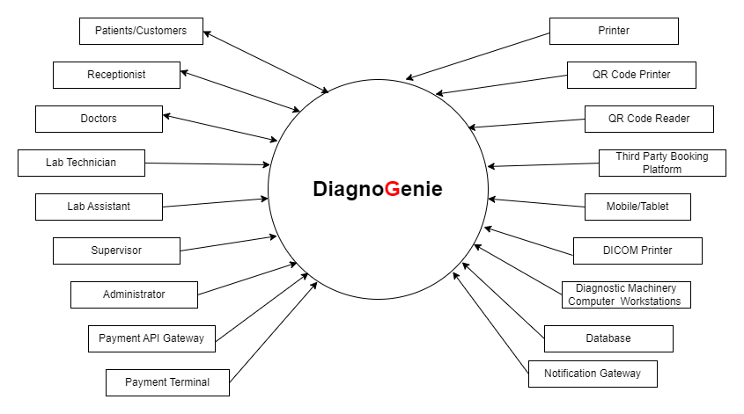

Figure 2.2 Context diagram of DiagnoGenie

* Patients can schedule their tests at the laboratory either by walking in or contacting the receptionist via phone call.
* The receptionist will be scheduling the tests for the walk-ins and customers connected via phone call.
* The doctors have access to the patients reports, which they can review.
* The lab technicians are responsible for analyzing the tests in their respective departments and uploading the results into the system.
* The lab assistants conduct the tests for walk-in patients or house calls and update the status of the sample collection.
* A supervisor manages the inventory, adding new stock, updating existing stock, and ordering necessary equipment for the laboratory.
* The administrator is responsible for setting up and maintaining the entire DiagnoGenie system, creating logins for users, assigning roles and permissions, and managing system operations.
* Payment API gateways are implemented to enable various payment methods such as credit card, debit card, or wallets.
* The printers are used to print invoices after scheduling tests and test reports if customers want hard copies for their reference.
* The QR code printer and QR code reader are used to print the QR codes containing patient details and to retrieve those details, respectively.
* Third-party booking platforms are available to allow for booking tests and confirmations through collaboration with our system.
* Payment terminals are used for making payments at the reception and scheduling appointments.
* The Diagnostic Machinery Computer Workstation is a computer workstation that communicates with laboratory machines such as MRI, CT scanner, and others to retrieve the results.
* The database is used to store patient and payment details, audio, video, and image data, and the schedule of appointments.
* Notification gateway sends alerts and notifications to end-users, doctors, and other parties involved with the status of the test, test reports, DICOM files, and other relevant information.

## Dataflow Diagram of DiagnoGenie

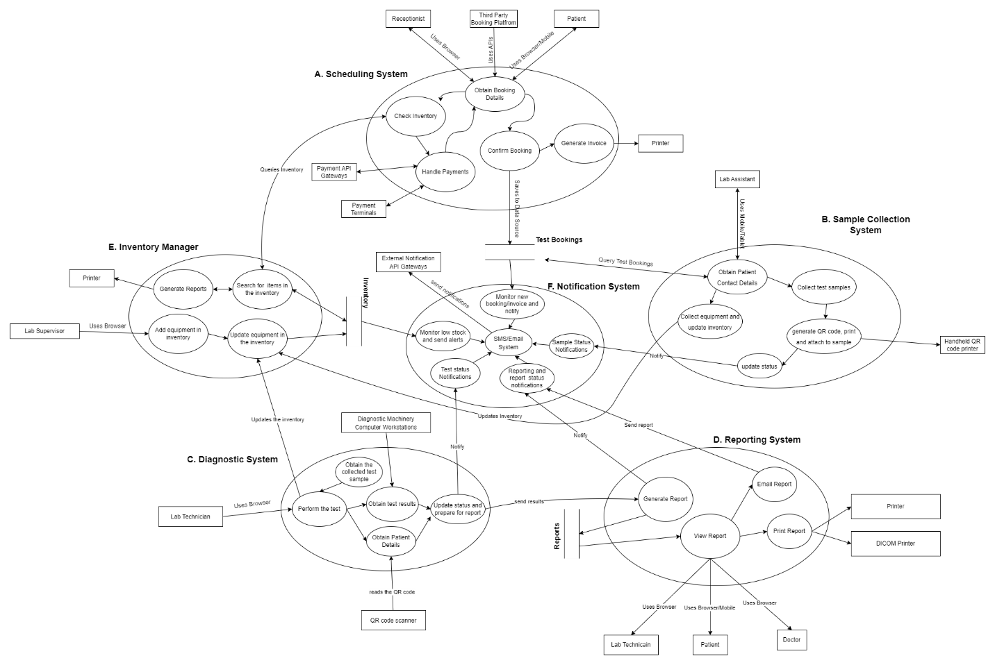

Figure 2.3.1 Dataflow Diagram

A data flow diagram (DFD) is a graphical representation of how data flows through a system or process. It is used to model the flow of information or data between different components of a system or organization.

The dataflow diagram (Figure 2.3.1) of DiagnoGenie consists of a total of 6 modules in it. They are as follows:

**A. Scheduling system:** This module deals with the scheduling procedure of the test either by receptionist, patient or through some collaborated third-party booking platforms.

**B: Sample collection system:** In this module, the Lab assistant performs the tests requested by the patient and updates the status of the test done. A hand held QR code printer is used to attach the details of the respective patient on the sample collected if necessary.

**C: Diagnostic System:** This is the main part where the tests diagnosis takes place i.e., the Diagnostic Laboratory and gives the results out. The Lab Technician will update the test results manually and looks after the updating of the reports. The Diagnostic Machinery Computer Workstation is used to get the results from the different equipment in the lab.

**D: Reporting System:** Here the results sent from the diagnostic system can be viewed, sent to the patients via mail or SMS and print the reports using the printer or the DICOM printer.

**E: Inventory Manager:** It is used to maintain the availability of the inventory by the Supervisor of the laboratory. Also, the system checks if the test is available or not based on the equipment of inventory.

**F: Notification System:** This system helps to communicate between the customer i.e., the laboratory and the patient via e-mail or notifications. It helps the patients to know about the updates on their tests and receive their reports by e-mail. It also helps the supervisor to monitor regarding inventory.

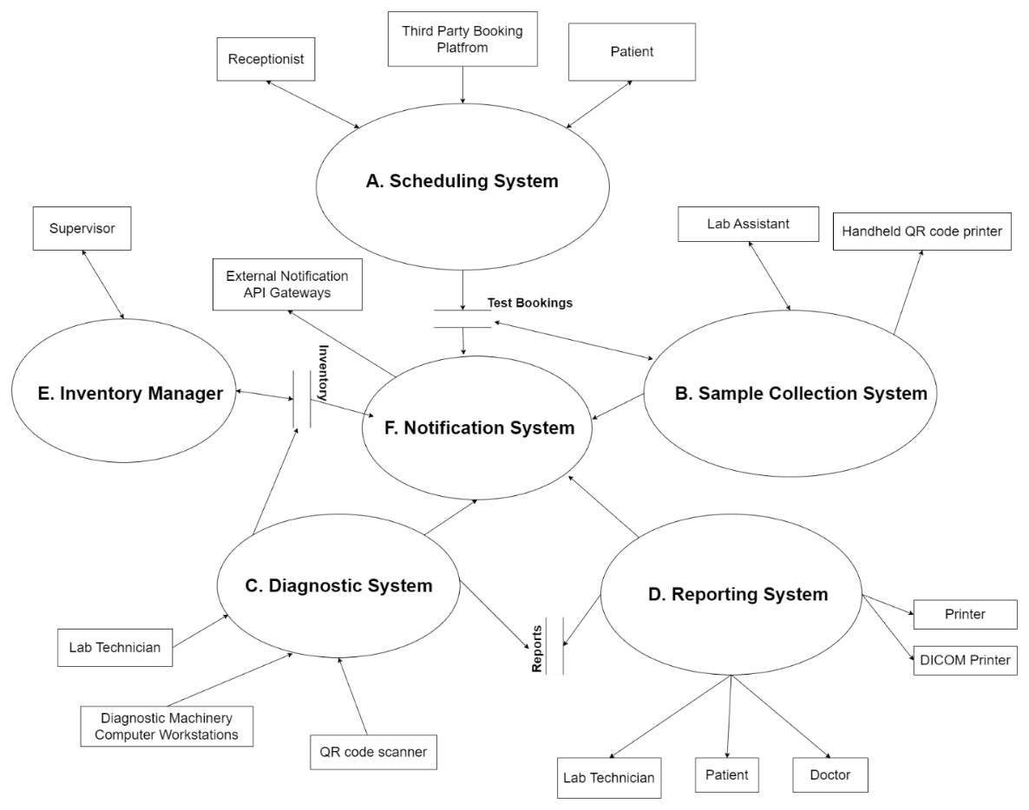

**Figure 2.3.2 Dataflow Diagram Overview**

The above Figure 2.3.2, is the detailed picture of the flow of the system. To make it more clearly understandable, we are going to divide it into smaller modules as show in the following figures.

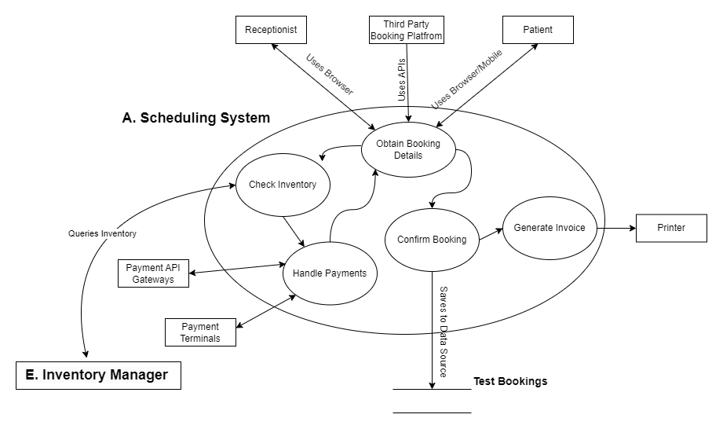

**Figure 2.3.3 Dataflow Diagram for Scheduling System**

The above Figure 2.3.3 gives a clear understanding of the Scheduling system.

* The scheduling of a test can be done through three actors - Receptionist, Third Party Booking and Patient.
* The receptionist uses browser to interact with the system. The third-party platforms connects and schedules using the APIs. The patients uses either their mobile or browser to schedule a test.
* The patient requests for the one or more tests to be done as per the diagnosis required and suggested by the doctor.
* The inventory manager is used to check the inventory and let the patient know if it is available or not while they are selecting the tests required.
* The patient selects the available tests from the list and proceeds to the payment if they are scheduling it via a mobile or browser or the third-party booking platforms. Now the Payment API Gateways are used to select from multiple options like credit card, debit card, UPI (available in India).
* If the tests are selected at the receptionist's front desk, the payment is done via the payment terminals i.e., the credit/debit card swiping machines which accepts credit card, debit card and UPI.
* Once the confirmation is received that payment is received, the booking is confirmed and saved in the database. The invoice is generated and sent to the e-mail provided by the patient using the notification system. The printer can be used to print the invoice with confirmation if the patient requests to.

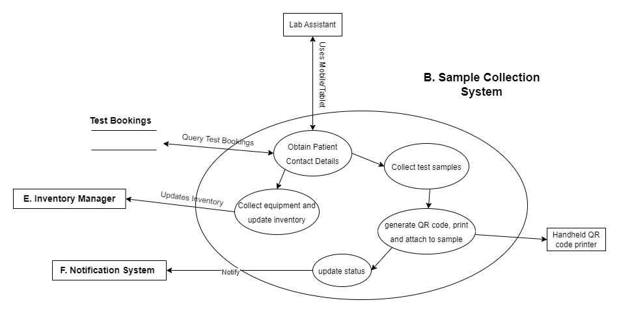

**Figure 2.3.4 Dataflow Diagram for Sample Collection System**

The Sample collection system can be easily comprehended from the diagram presented in Figure. 2.3.4. Here this system refers to the process of collecting and handling patient samples for laboratory testing. This system is a critical part of the diagnostic process and must be carefully managed to ensure accurate and reliable test results.

* The Lab Assistant uses as mobile or table to access the DiagnoGenie system with his credentials.
* He/she obtains the patient details with contact information. Now checks for the tests bookings and get the details.
* Collects the equipment from the inventory required and updated the inventory.
* Now lab assistant will collect the test samples from the laboratory or from the home of the patient if opted for it.
* Once collected, the samples are carefully stored to make sure it does not give false end results.
* A QR code is generated with the patient details to identify the samples from a batch of samples.
* The Handheld QR code printer is used in order to print the generated QR code to distinguish between the samples and attached on the exterior container of the samples collected.
* Finally, the update of the status like sample collected, reached the facility, sample test is in progress. It will notify the patients using the notification system.

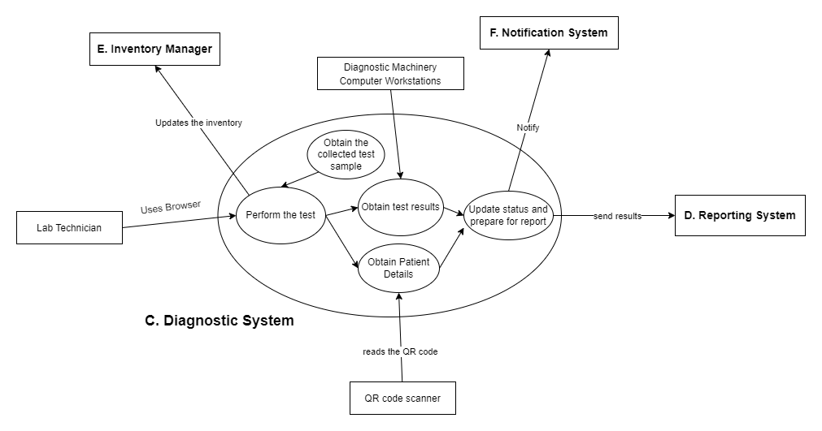

**Figure 2.3.5 Dataflow Diagram for Diagnostic System**

Let's begin discussing diagnostic system using the above Figure. 2.3.5 as a reference. Lab technicians play a critical role in the diagnostic laboratory manager by providing accurate and reliable laboratory testing and contributing to the delivery of high-quality patient care.

* The collected samples reside at the laboratory where the Lab Technician performs the tests and obtains the results.
* The Lab Technician uses as mobile or table to access the DiagnoGenie system with his credentials.
* He/she is responsible for processing patient samples using specialized laboratory equipment and techniques to extract and prepare the relevant analytes for testing.
* The equipment used for preparing the analytes and other tools used are to be updated in the inventory manager once utilized.
* The results are obtained in two ways. Manually, the lab technician performs some analysis on the tests done and number are read. The other results are directly retrieved from the Diagnostic Machinery Computer Workstation which is used to get the results from the different equipment present in the lab.
* Once all the results are obtained, the QR code scanner is used to obtain the patient details from the samples collected.
* After the preparation of the report by the lab technician, reports are stored in the database. The status of the test is updated and the reports are sent to the patient via SMS and e-mail through the notification system.

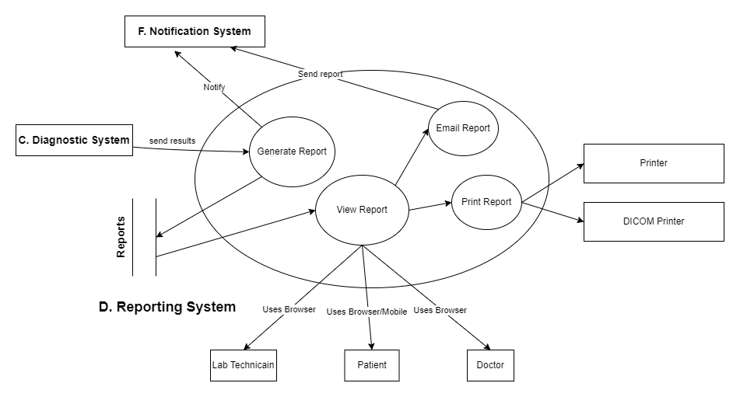

**Figure 2.3.6 Dataflow Diagram for Reporting System**

Referring from the above Figure. 2.3.6 let’s discuss about reporting system.

* The reports are generated by the lab technician after performing thorough analysis and conclusions.
* The reports are stored in the database once analysis is done.
* The Diagnostic system sends the results to the reporting system in order to send the view, print and send the report to the required persons in the system.
* The reports contain several types of files like the images, audio clips, videos, DICOMs, pdf, text files and many more.
* The report generated can be viewed in the web page using several viewers present in the web.
* The web DICOM viewer is used to view the DICOM on the online by the doctors, patients and the lab technicians.
* The status is to be sent to the patient that it can be collected at the lab or can be viewed online via a SMS or e-mail.
* The reports are sent to the patients using the notifications system through an e-mail.
* The reports can viewed by the doctors, patients and the lab technicians who conducted the analysis on the test.
* The reports can be printed in the laboratory and given to the patients if required using a printer.
* The DICOM printer is used in order to print the X-rays using the extracted DICOM files from the Diagnostic Machinery Computer Workstation.

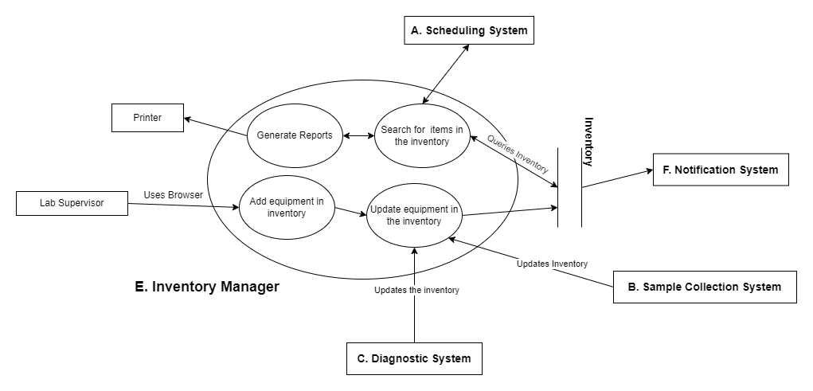

**Figure 2.3.7 Dataflow Diagram for Inventory Manager**

The inventory manager plays an essential role in ensuring the efficient and effective management of laboratory supplies and inventory, enabling the laboratory to provide high-quality diagnostic services to patients. Their main purposes include maintaining adequate inventory levels, preventing stockouts, cost management, ensuring regulatory compliance, implementing efficient inventory management systems and collaborating with other departments.

Let's begin discussing inventory system maintained by the Supervisor of the diagnostic laboratory using the above Figure. 2.3.7 as a reference.

* The Lab Supervisor uses as mobile or table to access the DiagnoGenie system with his credentials.
* Now the supervisor will be able to add the equipment and its quantity in the inventory and save them in the database.
* Will be able to update the inventory’s equipment also.
* The supervisor can generate reports of the stock available in the inventory and print it using the printer and get the daily reports.
* He/she will get a notification via the e-mail and SMS whenever there is low stock in the inventory using the notification system.
* The scheduling system will search for the necessary equipment is available or not in the inventory and then only it will schedule an appointment to the patient.
* The sample collection system, diagnostic system will update the inventory through Lab assistant and Lab technician respectively after using the equipment from the inventory.

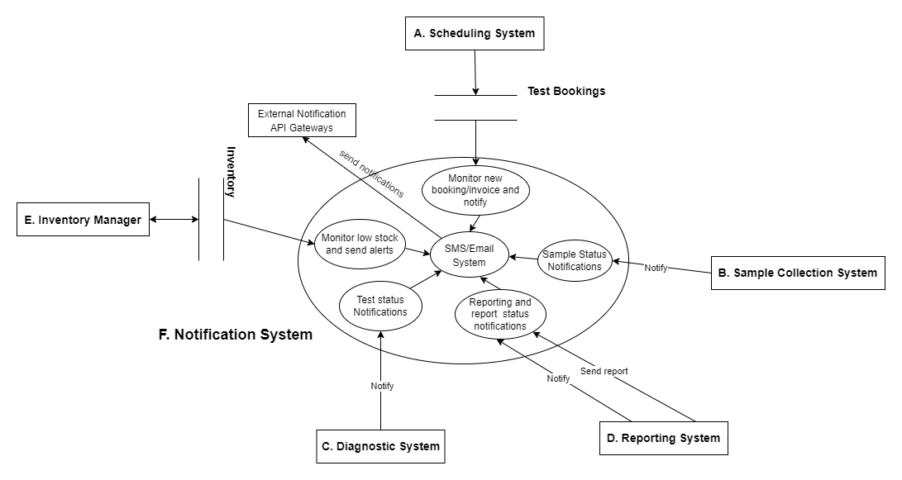

**Figure 2.3.8 Dataflow Diagram for Notification System**

The notification system involves the external notification API gateways which acts as tools that enable software applications to send notifications or alerts to external systems or services. They provide a standardized interface for communication, manage notification sending and receiving, ensure security, format data, handle errors, and monitor notification status. The notification system how it has been used can be explained below using the Figure. 2.3.8.

* There are external API gateways used for the notification sending like SMS or an e-mail in order to let the patients know the progress of the tests they went through.
* The Scheduling system once the booking is confirmed will generate the invoice as a pdf and sends it to the patients mail address and mobile number provided during the process of signup using the notification. It takes the data from test bookings and does this.
* In the sample collection system, the lab technician will have to update the status of the test requested by the patient like sample collected, reached the facility, sample test is in progress.
* The inventory manager will have to alert the supervisor if the stocks are low in the inventory so that they have adequate inventory for tests to run.
* In the diagnostic system, the lab assistant will send the notification to the patients that the reports ready to be collected via the notification system.
* The reporting system sends the various reports attachments to the patients via the e-mail like the audio, video, pdfs, DICOMs, using the notification system.

# DG Use Case Scenarios

## D-G < Patient Booking an appointment online >

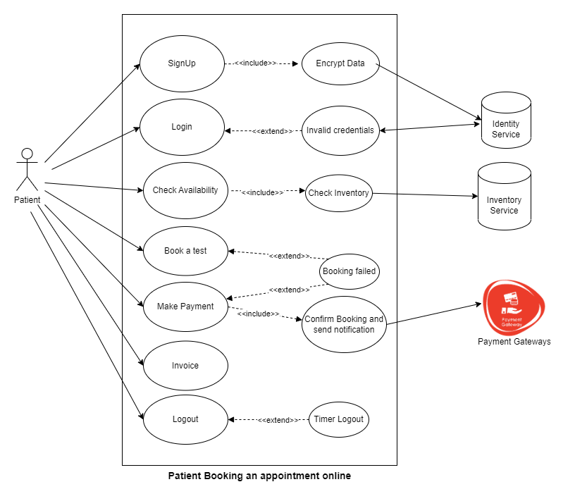

**Figure 3.1.1 Patient booking an appointment online**

* The above figure 3.1.1 represents the use case patient booking an appointment online.
* This use case covers ***Functionality*** requirements.
* Patient will be able to Sign up with his personal details and can login to the system with his/her credentials.
* For a patient booking a test online, he/she will check the availability of the test by checking the inventory.
* If the test is available, patient will be able to book the test and the next step is to make the payment.
* The patient will make the payment and the confirmation will be notified and he/she can generate the invoice.
* The patient can logout from the system or it will be automatically logged out by the timer.

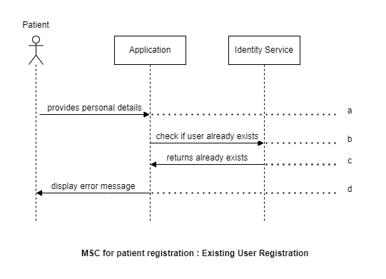

**Figure 3.1.2 Existing user registration**

The above figure 3.1.2 represents the scenario of implementing the patient registration for already existing users.

1. The patient can provide the personal details in the application for the registration which will be evaluated.
2. The application checks the provided details with the already existing patient’s information in the data base using the identity services.
3. Identity services provides the feedback to the application on the patients details if they are new or details of a already existing patient.
4. If the details are same as the already existing patient, then application displays a error message to the patient about the matching of the information.

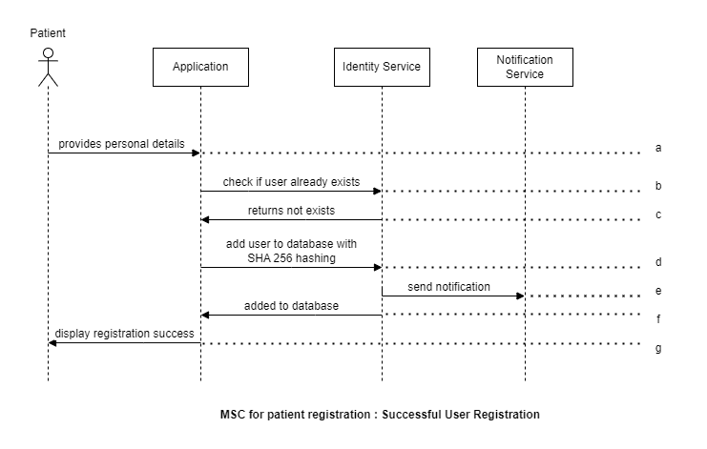

**Figure 3.1.3 Successful user registration**

The above figure 3.1.3 represents the scenario of implementing the Successful patient Registration.

1. The patient will provide the personal details in the application for the registration.
2. The application checks the provided details with the already existing patient’s information in the data base using the identity services.
3. Identity services provides the feedback to the application confirming the details provided is unique and does not exist in the database.
4. The application then sends an instruction to identity services to add the user information into the database using the SHA 256 hashing for security.
5. The identity services sends notification on adding the details to the database.
6. A confirmation is provided to the application from the identity services on adding the new patient data to the database.
7. The successful registration of the new patient is displayed on the application to the user.

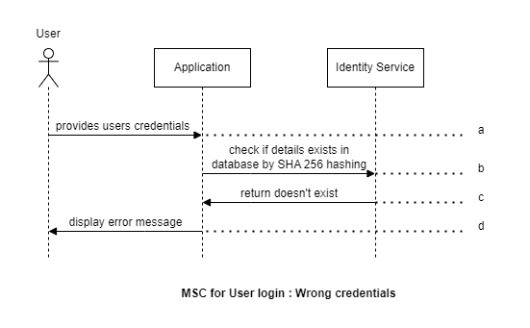

**Figure 3.1.4 User entering wrong credentials**

The above figure 3.1.4 represents the scenario of implementing the User login with the wrong credentials.

1. The user provides login credentials in the application for the login into the DiagnoGenie services.
2. The application sends a request to the identity services to check the provided credentials with the already existing patients’ credentials using the SHA 256 hashing.
3. Identity services provides the feedback to the application request confirming the credentials provided does not exist in the database.
4. The application then displays an error message on the screen for the user about the wrong login credentials.

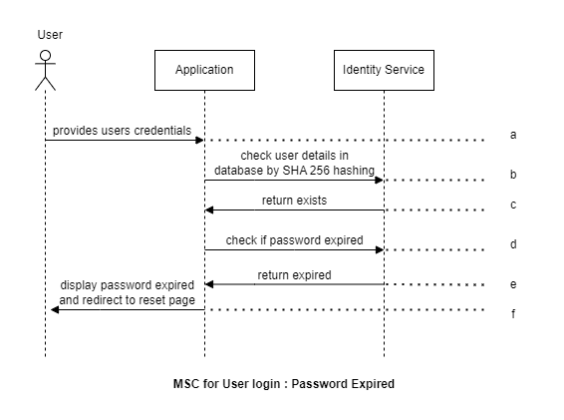

**Figure 3.1.5 User login with expired password**

The above figure 3.1.5 represents the scenario of implementing the User login with the Expired Password.

1. The user provides login credentials in the application for the login into the DiagnoGenie services.
2. The application sends a request to the identity services to check the provided details with the already existing patients’ details using the SHA 256 hashing.
3. Identity services provides the feedback to the application confirming the patient details exists in the database.
4. Then application sends a request to the identity services to validate if the password is expired.
5. Identity services provides the feedback to the application that the password is expired.
6. The application displays a notification that the password is expired and they need to reset the password.

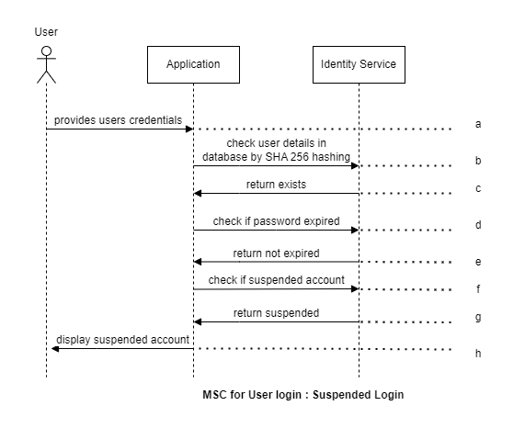

**Figure 3.1.6 Suspended user login**

The above figure 3.1.6 represents the scenario of implementing the User login with the Suspended login credentials.

1. The user provides login credentials in the application for the login into the DiagnoGenie services.
2. The application sends a request to the identity services to check the provided details with the already existing patients’ details using the SHA 256 hashing.
3. Identity services provides the feedback to the application confirming the patient details exists in the database.
4. Then application sends a request to the identity services to validate if the password is expired.
5. Identity services provides the feedback to the application that the password is not expired.
6. Now application sends another request to the identity services to validate if the provided credential is of suspended account.
7. Identity services replies to the application that the provided login credentials are suspended.
8. The application displays a notification to the user that the login credentials used are of suspended account.

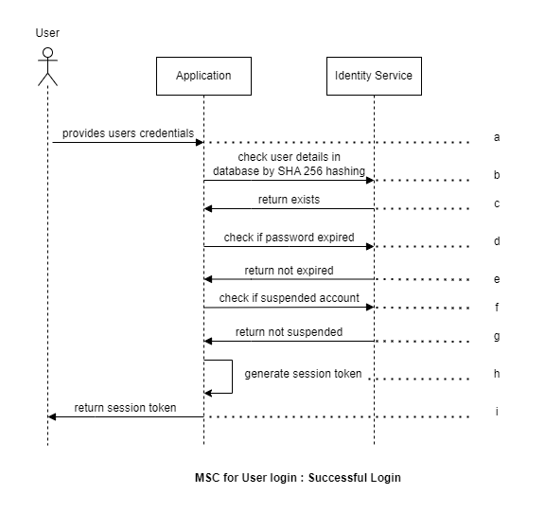

**Figure 3.1.7 User successful login**

The above figure 3.1.7 represents the scenario of implementing the successful User login with the credentials.

1. The user provides login credentials in the application for the login into the DiagnoGenie services.
2. The application sends a request to the identity services to check the provided details with the already existing patients’ details using the SHA 256 hashing.
3. Identity services provides the feedback to the application confirming the patient details exists in the database.
4. Then application sends a request to the identity services to validate if the password is expired.
5. Identity services provides the feedback to the application that the password is not expired.
6. Now application sends another request to the identity services to validate if the provided credential is of suspended account.
7. Identity services responds to the application that the give login credentials are not suspended account.
8. Now the application creates a session token for the user login and use that token to keep the user actively connected to the services.
9. The application returns this session token to the user interface.

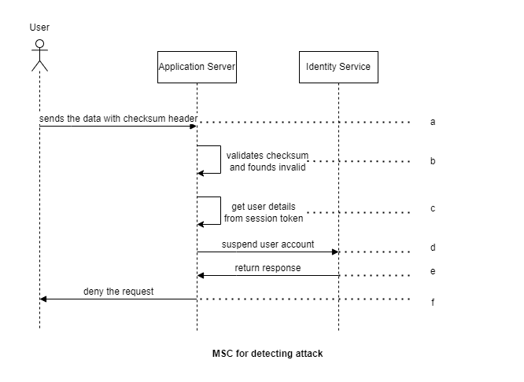

**Figure 3.1.8 Detecting attack**

The above figure 3.1.8 represents the scenario of detecting the attack on the application.

1. The user sends the request packets with checksum header to the application.
2. The application validates the authenticity of the check sum headers and finds they are invalid type.
3. Now application gathers the user information from the session token generated during login.
4. The application sends a request to the identity services to suspend the user account with the details from the session token.
5. Identity services provides the feedback to the application that the user account is suspended.
6. The application denies the packet request from the user and suspends their account.

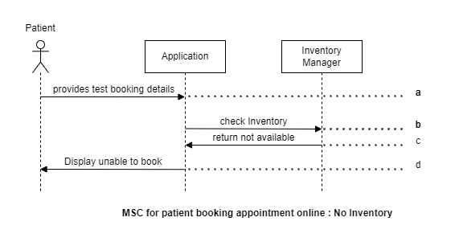

**Figure 3.1.9 Booking appointment failure due to no inventory**

The above figure 3.1.9 represents the scenario of implementing the online appointment when there is no inventory.

1. The patient once logged in can provide the details for tests booking in the application.
2. Application sends a request to the inventory to check for the availability.
3. The application receives the response that the inventory is not available for the requested test.
4. The application displays the information on unavailability of the inventory to the user.

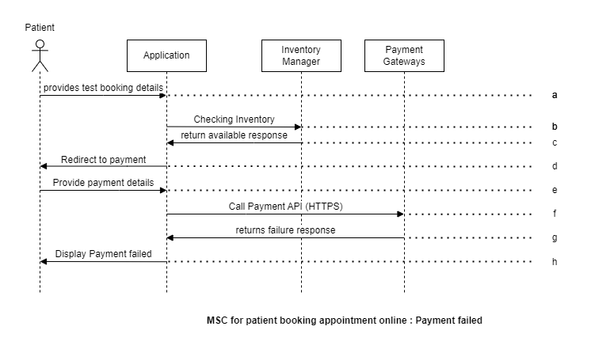

**Figure 3.1.10 Payment failure for patient booking appointment online**

The above figure 3.1.10 represents the scenario of implementing the online appointment booking when the payment failed.

1. The patient once logged in, can provide the details for tests booking in the application.
2. Application sends a request to the inventory to check for the availability.
3. The application receives the response from the inventory on availability for the requested test.
4. The application now redirects the user to the payment gateway page to enter the details.
5. The user provides the needed details to complete the payment for the services.
6. Application calls the payment API to complete the payment with Payment gateway.
7. Payment gateway returns the transaction failure status to the application.
8. The application displays the same payment failure message to the user.

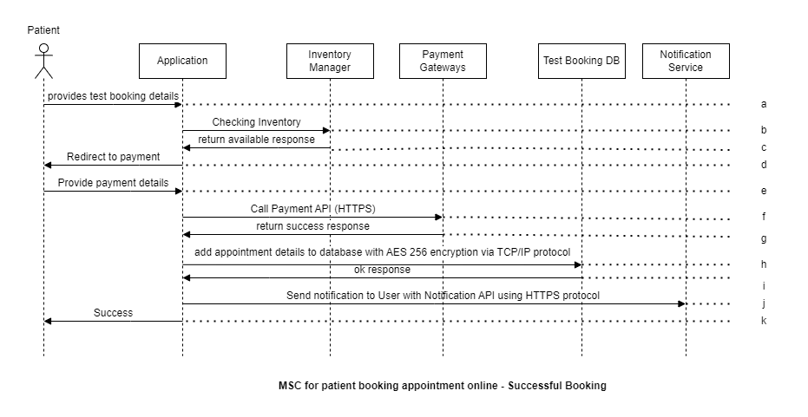

**Figure 3.1.11 Successful appointment booking**

The above figure 3.1.11 represents the scenario of implementing the online appointment booking when the payment is successful.

1. The patient once logged into the application can provide the details for tests booking.
2. Application sends a request to the inventory to check for the availability.
3. The application receives the response from the inventory on availability for the requested test.
4. The application now redirects the user to the payment gateway page to enter the details.
5. The user provides the needed details to complete the payment for the services.
6. Application calls the payment API to complete the payment with Payment gateway.
7. Payment gateway returns the transaction successful status to the application.
8. Application now adds these transaction details to the test booking database with the AES 256 Encryption via TCP/IP protocol.
9. The application gets confirmation on adding these details to the test booking database.
10. The application finally displays the payment successful message to the user.

## D-G < Receptionist Booking a walk-in appointment >

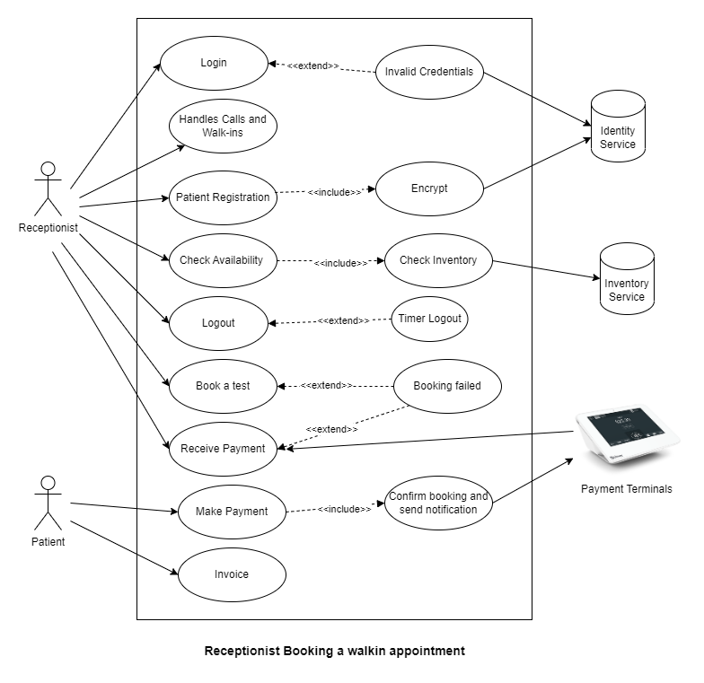

**Figure 3.2.1 Receptionist Booking a walk-in appointment**

* The above figure 3.2.1 represents the use case for patient booking a walk-in appointment.
* This use case covers ***Functionality*** requirements.
* When a patient wants to book a walk-in appointment, receptionist will login to the system with the credentials.
* Receptionist can check the availability of the test which checks the inventory and if it is available, then the receptionist registers the patient with personal details.
* After registering the patient, receptionist will ask the patient for payment and receives it from the payment terminals.
* On successful booking of an appointment confirmation is send via notification to the patient and receptionist can generate and print invoice.

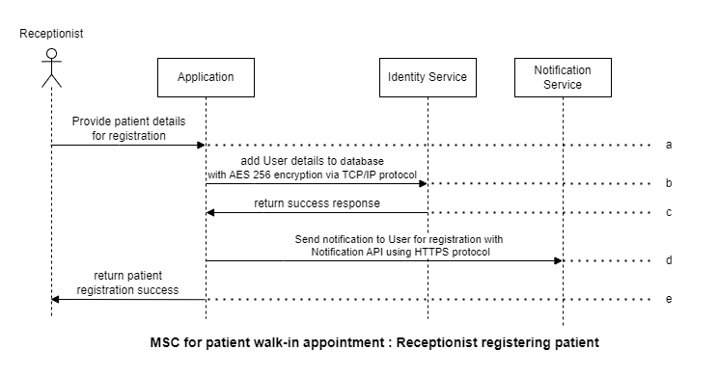

**Figure 3.2.2 Receptionist registering patient in walk-in appointment**

The above 3.2.2 figure represents the how the receptionist will register the patient details at the walk-in appointment through the application.

1. Receptionist will provide the patient details for registration to the application by creating or signup the account.
2. The application will add the patient details to the database by using the AES 256 encryption via TCP/IP protocol.
3. The server will give you the return response to the application by creating the patient details.
4. The application will send a notification to the user for registration with the notification API using the HTTPS protocol.
5. The application will send a notification to the receptionist as success by registering the patient details.

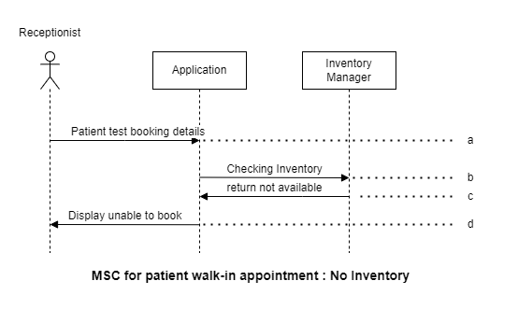

**Figure 3.2.3 Booking appointment failure due to no Inventory**

The above 3.2.3 figure represents how the receptionist will get the no inventory while trying to book the walk-in appointment

1. The receptionist will book a test, using details of a patient through the application.
2. The application will check the inventory in inventory manager module according to the patient test details.
3. The inventory manager module sends the response according to the availability of the inventory to the application.
4. The application will display the response as unable to book if the inventory is not available.

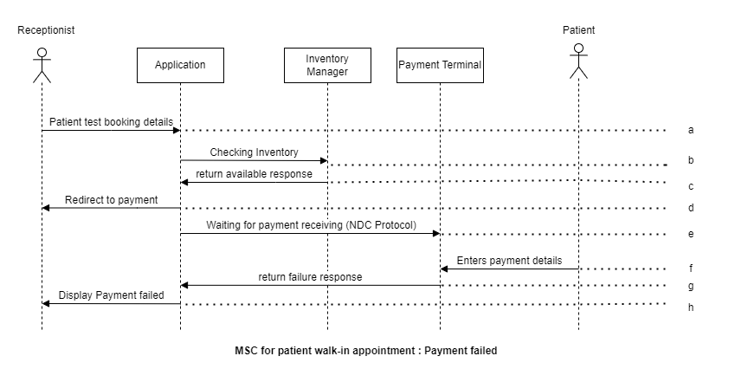

**Figure 3.2.4 Payment failure in walk-in appointment**

The above figure 3.2.4 figure represents how the payment terminal will fail while booking the walk-in appointment for patients.

1. The receptionist will book the test through the application.
2. The application will check the inventory with inventory manager.
3. The inventory manager will send the send the response the of the availability to the application.
4. The application will redirect to the payment terminal to pay the amount of the books test through the application.
5. The application will send a request to the payment terminal through the NDC protocol.
6. The patient will enter the payment details with payment terminal.
7. The payment terminal will send the failure response to the application. When the payment is failed.
8. The application will display the payment failed response to the receptionist.

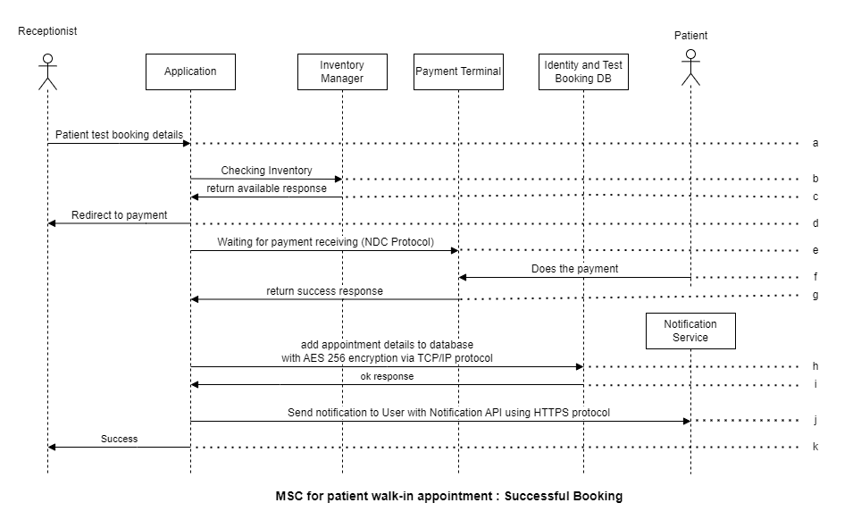

**Figure 3.2.5 Successful booking of walk-in appointment**

The above 3.2.5 figure represents how the receptionist will book the walk-in appointment with the successful booking response through the application.

1. The receptionist will book the lab test through the application with patient details.
2. The application will check with the inventory manager regarding the test related inventory is available or not.
3. The inventory manager will send the response of availability of inventory to the application.
4. The application will redirect you to the payment gate way.
5. The application will be waiting for the payment by using the NDC protocol.
6. The patient will do the payment with the payment gateway which is integrated with the application.
7. The payment terminal will send a success response to the application
8. The application will add the appointment to the DB with AES 256 encryption via TCP/IP protocol.
9. The test booking DB will send the success response to the application.
10. The application will send the notification to the patient with the notification API using HTTPS protocol.
11. The application will send the success response.

## D-G < Lab assistant collecting test samples >

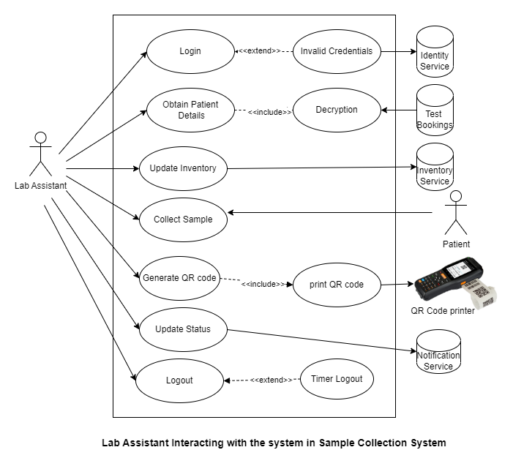

**Figure 3.3.1 Lab Assistant interacting with the system in Sample Collection System**

* The above figure 3.3.1 represents the use case for lab assistant collecting the samples from the patients.
* This use case covers ***Functionality*** requirements.
* After the patient books the test, the test samples need to be collected. The samples are collected by the lab assistant either at patient home or at the laboratory.
* In order to collect the test sample, the lab assistant need to obtain the patient details and then update the inventory after collecting the necessary equipment.
* After collecting the sample from the patients, lab technician prints a QR code with QR code printer which contains and the patient and the test information.
* After collecting the sample, lab technician updates the status of the test as sample collected and notification will be sent. All these collected samples will be sent to the laboratory for testing.

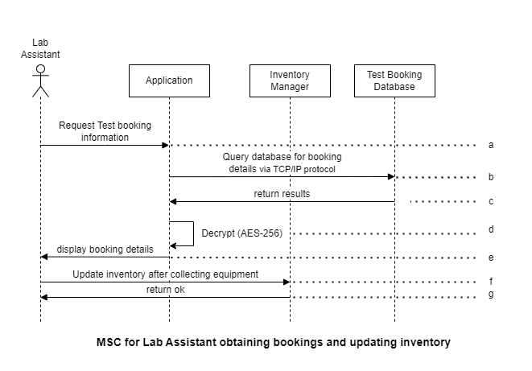

**Figure 3.3.2 Lab Assistant obtaining bookings and updating inventory**

The above 3.3.2 figure represents how the lab assistant obtaining bookings and update the inventory with inventory manager through the application.

1. The lab assistant will request the test booking information through the application to the test booking database.
2. The application will send the query to the database via TCP/IP protocol for booking the test.
3. The test booking database will send the response to the application.
4. The application will decrypt the results using AES-256.
5. The application will display the booking details which are the response from the test booking database.
6. The lab assistance will update the inventory through the application to inventory manger after collecting the equipment.
7. The inventory manager will sends the response ok the lab assistant through the application.

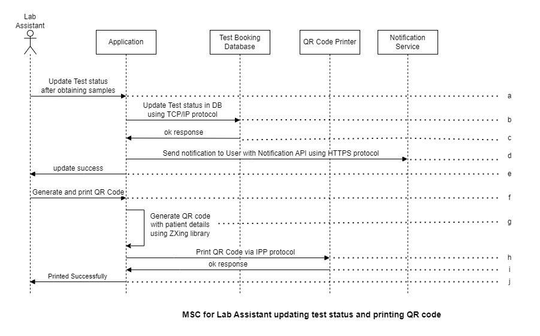

**Figure 3.3.3 Lab Assistant updating test status and printing QR code**

The above 3.3.3 figure represents how the lab assistant updating the test status and printing the QR code with interacting with the test booking database, QR code scanner and notification service through the application.

1. The lab assistant will update the test status after obtaining the samples through the application
2. The application will update the test status in the database using the TCP/IP protocol to the test booking Database.
3. The test booking Database will send the update response to application.
4. The application will send a request to the notification service to send the notification to the user with Notification API using the HTTPS protocol.
5. The application will send a response of success update to the lab assistant about the updating.
6. The lab assistant will request the QR code to generate or print through the application.
7. The application will generate the QR code with patient details using the ZXing library
8. The application will send a request to print QR code via IPP protocol to QR printer module.
9. The QR printer will send you the success response to the application.
10. The application will display the response of printed successfully.

## D-G < Lab Technician performing the test >

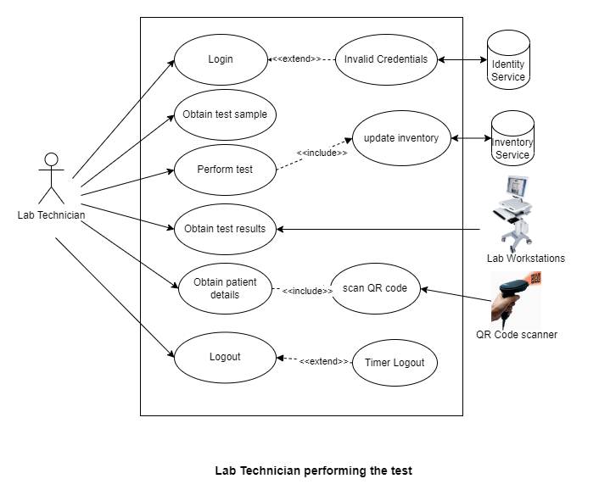

**Figure 3.4.1 Lab Technician performing the test**

* The above figure 3.4.1 represents the use case for lab technician performing the test.
* This use case covers ***Functionality*** requirements.
* Once the test samples are brought to the lab, lab technician will obtain the test samples.
* Before performing the test, lab technician will collect the necessary equipment and updates the inventory.
* Lab technician will perform the test and the results are obtained from the laboratory workstations.
* Once the results are identified, lab technician scans the QR code using QR code scanner and obtains the patients results.
* With the obtained patient details and the test results, lab technician will be able to generate the report.
* Once this is done, lab technician will update the status that the testing is completed and a notification will be send to the patient.

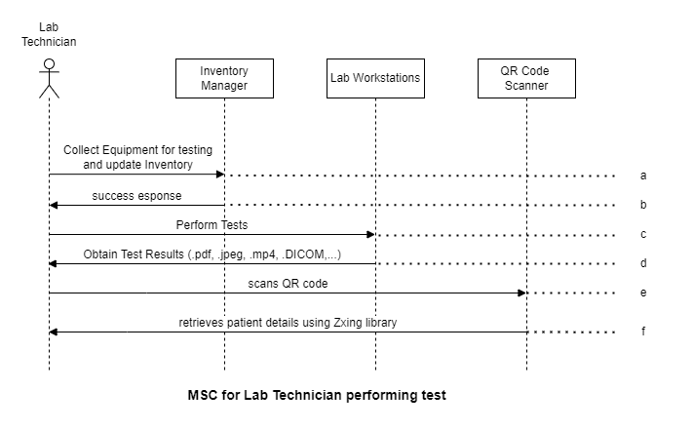

**Figure 3.4.2 Lab Technician performing test**

The above 3.4.2 figure represents the lab technician performing the report using the inventory and QR code scanner through the application.

1. The lab technician will collect the equipment for testing and update inventory to the inventory manager.
2. The inventory manager will display the success response to the lab technician.
3. The lab technician will perform the test through the lab workstations.
4. The lab technician will obtain the test results through the lab workstations in the form of pdf, jpeg, mp4, etc.
5. The lab technician will send a request to the QR Code scanner to scan the QR code.
6. The QR code scanner will send a response of retrieving the patient details using the Zxing Library to lab technician.

## D-G < Accessing the Report >

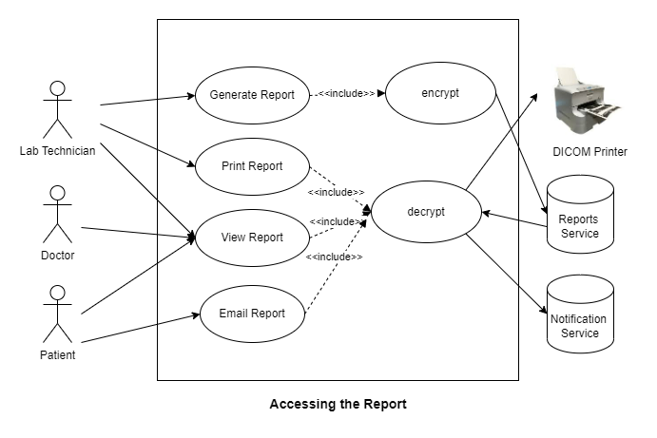

**Figure 3.5.1 Accessing the report**

* The above figure 3.5.1 represents the use case for accessing of the reports by different actors.
* This use case covers ***Functionality*** requirements.
* Once the test results are generated, lab technician will generate the report. These reports contain the personal information and the encrypted before storing.
* If required, the reports are printed. Some of the reports like X-rays, MRIs are printed using the DICOM printer.
* Doctor will be able to login to the system and view the patient report by searching for the patient report. Here reports are viewed in different formats like video, image, pdf, DICOM etc.
* Patient can also login to the system and can access the reports. Patient can also send his report to his personal email id.

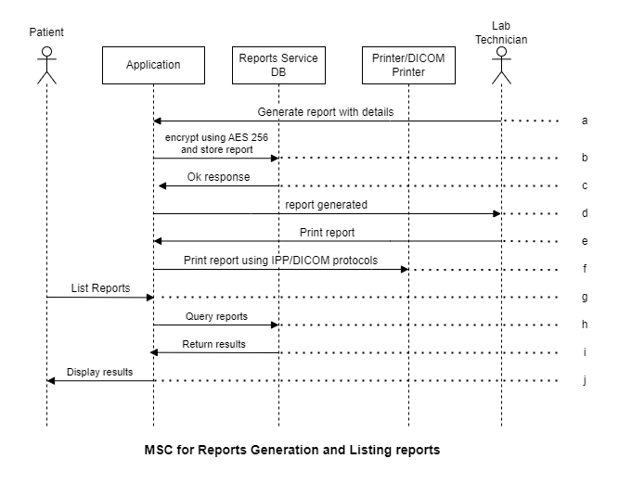

**Figure 3.5.2 Reports generation and listing**

The above 3.5.2 figure represents how patient and lab technician will generate and listing reports through the application.

1. The technician will generate the report with details to the application.
2. The application will encrypt using AES 256 and store the report to the reports service database.
3. The report service database will send the response to the application.
4. The application will send the response to the lab technician as report generated.
5. The lab technician will request the application to print the report .
6. The application will send the request to the printer /DICOM printer to print the reports using the IPP/DICOM protocols.
7. The patient will access the application for the list of reports.
8. The application will send request to the request service Database to query the reports.
9. The request service data base will send the response of requested reports results.
10. The application will display the reports the patient can view the reports through the application.

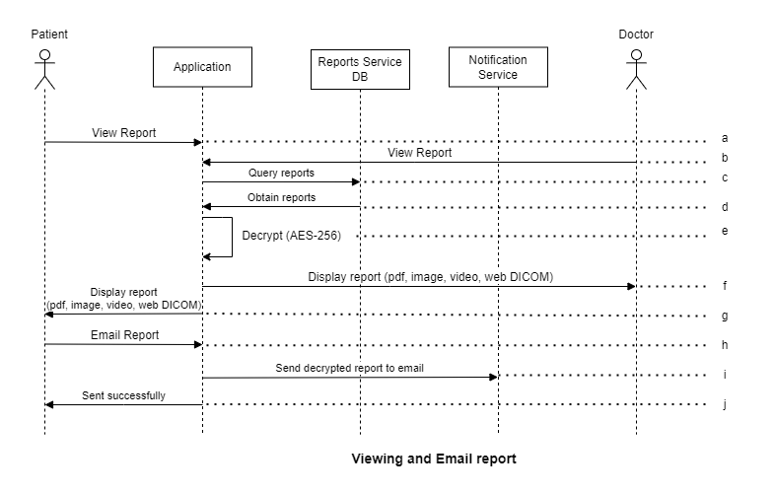

**Figure 3.5.3 View and email report**

The above 3.5.3 figure represents how the patient and doctor view and email the reports through the application.

1. The patient will view the report through the application
2. The doctor will view the patient report through the application
3. The application will send the request the request service to query the reports
4. The request service Database will send the response by obtaining the results to the application.
5. The application will decrypt the reports received from the request service Data base using AES-256.
6. The application will display the reports in pdf, image, video, web DICOM, etc to the doctor.
7. The application will also display the reports in pdf, image, video, web DICOM, etc to the patient.
8. The patient can also email the report through the application.
9. The application will send the decrypted reported email to the notification service.
10. The application send response of sent successfully to the patient.

## D-G < Lab Supervisor interacting with the system >

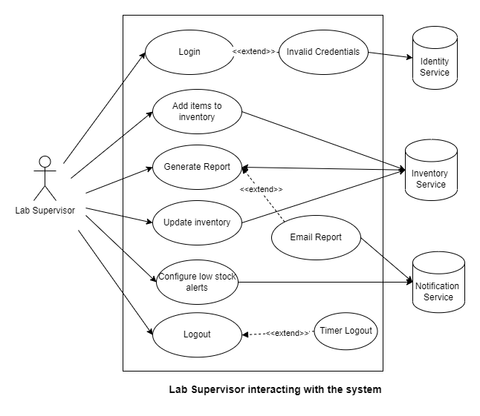

**Figure 3.6.1 Lab Supervisor interacting with the system**

* The above figure 3.6.1 represents the use case for lab supervisor interacting with system.
* This use case covers ***Functionality*** requirements.
* Lab supervisor will be able to login to the system using the credentials provided to them.
* Lab supervisor can add the items to the inventory when the new stock is arrived.
* Lab supervisor can generate reports on the existing inventory and can print them.
* When the equipment is being used for testing or sample collection, the inventory will be updated in the database.

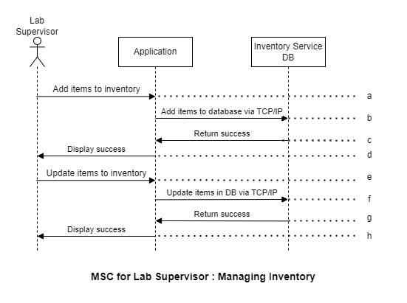

**Figure 3.6.2 Lab Supervisor managing the inventory**

The above 3.6.2 Figure represents how the lab supervisor interacts inventory service Database with the application for managing the inventory.

1. The lab supervisor will add the items to inventory through the application.
2. The application will add the items to the database via TCP/IP to the inventory service
3. The inventory service Database will send the response of success to the application.
4. The application will display the success response to the lab supervisor
5. The lab supervisor will update the items to the inventory through the application.
6. The application will update the items in Database via TCP/IP to the inventory service.
7. The inventory service will send the response of return success to the application.
8. The application will display the response of success to the lab supervisor.

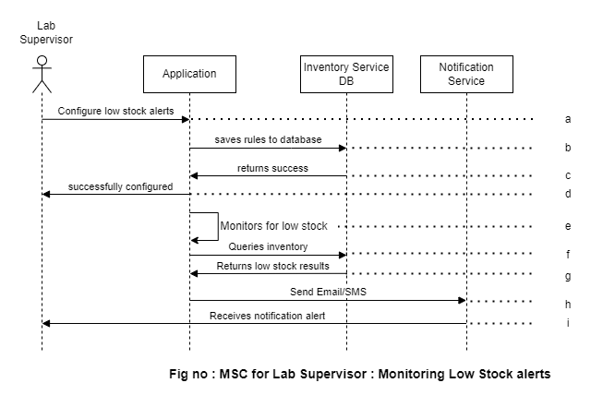

**Figure 3.6.3 Lab Supervisor configuring monitoring of low stock alerts**

The above 3.6.3 Figure represents how the lab supervisor interacts with application to configure and monitor the update of low stock alerts.

1. The supervisor will configure the low stock alerts to the application.
2. The application will send a request to the inventory service data base to save the rules of the low stock alerts.
3. The inventory service Database will send the response of success to the application.
4. The application will display the response of successfully configured to the lab supervisor from the inventory service database.
5. The application itself will monitor for low stocks and sends response to it.
6. The application will send the request of queries inventory to the inventory service database.
7. The inventory service database will send the response of low stock results to the application.
8. The application will send the request to the notification service to send the email/SMS.
9. The notification service will send the response to the lab supervisor through the application. and the lab supervisor receives the notification alert from the application.

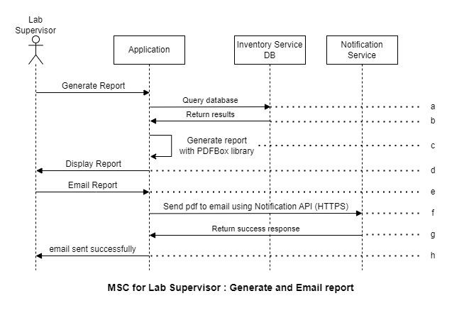

**Figure 3.6.4 Lab Supervisor report generation and sending e-mail of report**

The above 3.6.4 Figure represents how the lab supervisor will generate and email the report through the application.

1. The lab supervisor will generate the report through the application and the application will send a request of query database to the inventory service Database.
2. The inventory service Database will return the results to the application.
3. The application will generate the report using PDFbox library.
4. The application will display the report to the lab supervisor
5. The lab supervisor will email the report through the application
6. The application will send the request to notification service to send the pdf to email using the API(HTTPS).
7. The notification service will send the success response to the application.
8. The application will send the notification alert to the lab supervisor and sends the response of email sent successfully.

## D-G < System Administrator providing identity access >

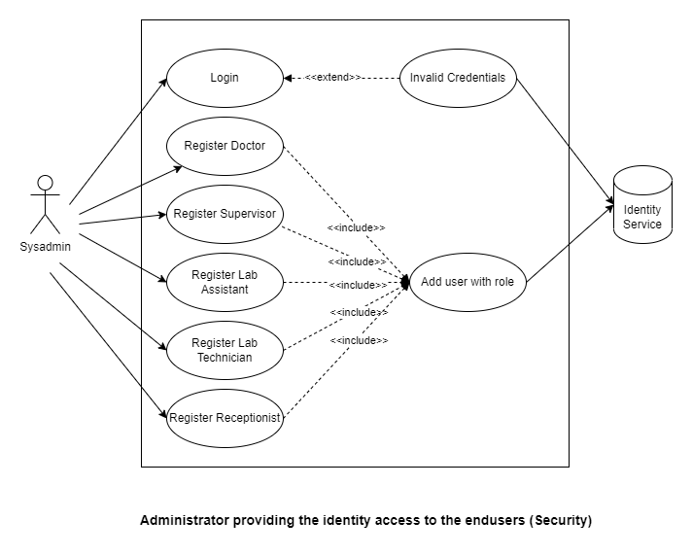

**Figure 3.7.1 System Administrator providing identity access**

* The above figure 3.7.1 represents the use case for system administrator providing identity access to the end users.
* This use case covers the ***Security*** aspect of the requirements.
* Sysadmin can login to the system using his credentials.
* Sysadmin can provide the access to different users with their respective role.
* Different kinds of users include Doctor, Supervisor, Lab Assistant, Lab Technician, Receptionist.
* The identity credentials provided are added to the identity service database.

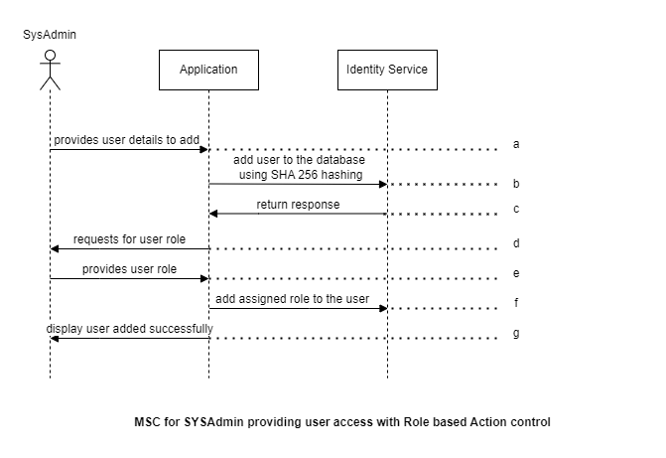

**Figure 3.7.2 Sysadmin providing user access with role based action control**

The above figure 3.7.2 represents the scenario of creating users and assigning roles to the users by the system administrator.

1. The system administrator will provide the details of the user to be added to the system through the application.
2. The details of the user to be added are added to the identity service by saving the details in the form of a hash using the SHA-256 hashing technique.
3. The provided details create a user and are added in the identity service and the response is sent to the application.
4. For the user created, the application requests to provide the role.
5. The system admin will provide the appropriate role for the user to the application.
6. The application will now add the role of the user provided by the system administrator in the identity service.
7. The application will return a message that the user is added successfully.

## D-G < System Administrator Operations Maintenance and Security >

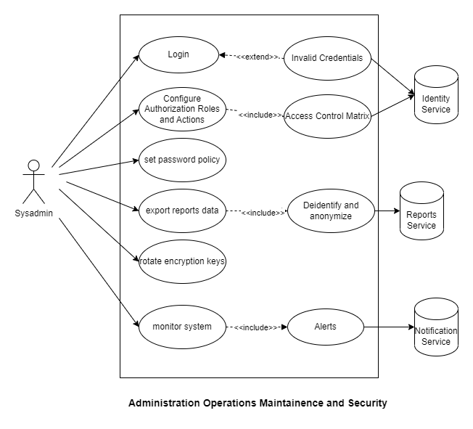

**Figure 3.8.1 Sysadmin Administration, Maintenance and Security**

* The above figure 3.8.1 represents the use case for Sysadmin doing operations and maintenance.
* This use case covers ***Security***, ***Application Operations and Maintenance*** requirements.
* The Sysadmin is able to login to the machine with his credentials.
* Sysadmin can configure who can do what in the form of Access Control Matrix i.e. Role Based Access Control.
* There are some operations and Management tasks like setting password policy, expiration time, exporting reports by anonymizing them, rotating encryption keys for encrypting the data.
* Some maintenance of the application like upgrading and downgrading and monitoring of the system is also done by System Administrator.

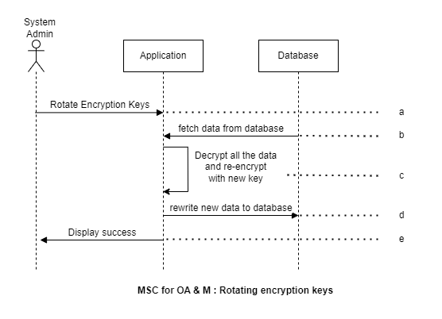

**Figure 3.8.2 Rotating encryption keys**

The above figure 3.8.2 represents the scenario of rotating the encryption keys in certain period of time to avoid attacks by the System administrator.

1. The system administrator will provide the newly generated keys which we call as the rotating encryption keys to re-encrypt all the data in the database through the application.
2. The application will fetch the data from the database.
3. Now, the fetched data will be decrypted will the previous key and will be re-encrypted with the new key.
4. The newly encrypted data with the new key will be written to the database again.
5. After all the process is done, the success message is displayed to the system administrator.

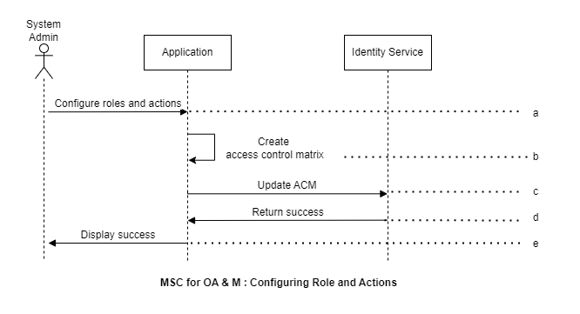

**Figure 3.8.3 Configuring role and actions**

The above figure 3.8.3 represents the scenario of configuring roles and actions to the users through creating the access control matrix by the system administrator.

1. The system administrator will set the configuration of the roles to the users and the actions to be performed by the users in the system through the application.
2. The application will generate an access control matrix to help ensure that subjects can only access objects that they are authorized to access, based on the access control policies of the system.
3. The application will update the identity service based on the access control matrix created.
4. The identity service will return a success message that roles and actions of the user are updated to the application.
5. The application will display a success message that roles and actions that can be performed by the users is updated to the system administrator.

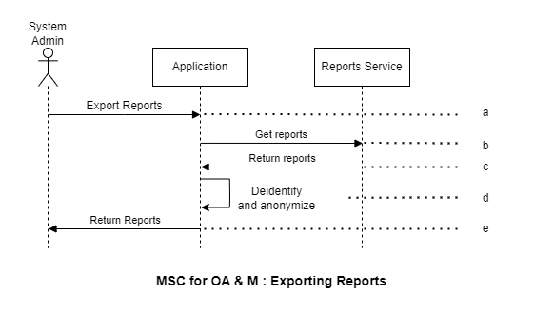

**Figure 3.8.4 Exporting reports**

The above figure 3.8.4 represents the scenario of exporting the reports by the system administrator.

1. The system administrator will export the data related to the users in the application in the form of the reports.
2. The application requests for the reports through the reports service.
3. The reports service will return the reports requested to the application.
4. The application will then deidentifies the users details and make them anonymous to keep the data confidential as this is to be used for training purpose only and the data is sensitive.
5. The deidentified anonymous reports created by the application are returned to the system administrator.

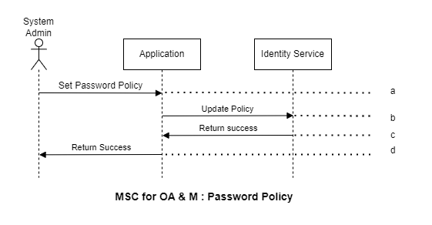

**Figure 3.8.5 Updating password policy**

The above figure 3.8.5 represents the scenario of creating the password policy by the system administrator.

1. The system administrator sets a password policy and save it in the application.
2. The application will update the password policy in the identity service.
3. The identity service will return a success message that policy is updated to the application.
4. The application will display a success message that policy is updated to the system administrator.

## D-G < Error Recovery >

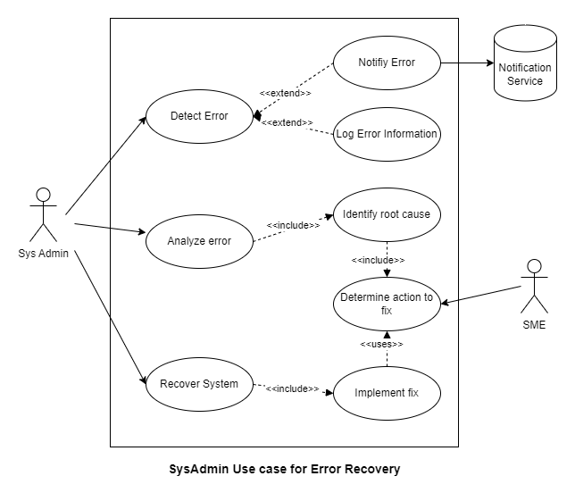

**Figure 3.9.1 Error recovery**

The above figure 3.9.1 represents the use case for error recovery of the application.

* This use case covers ***Error Recovery*** requirements.
* In the case of any error in the system, application will detect the error and then log the error. Sysadmin will be notified by sending a notification.
* In order to find the cause of the error, sysadmin will analyse the error and identify it by doing root cause analysis.
* In order to recover the system from the error, system admin need to determine the fix, this can be done with the help of the SMEs.
* Sysadmin will recover the system by implementing the fix identified.

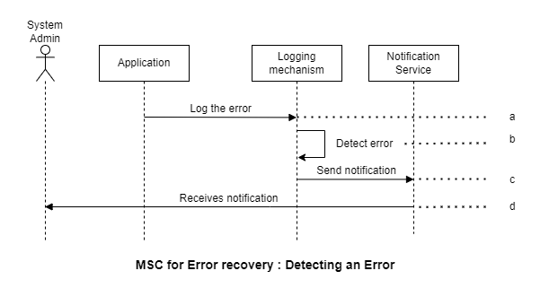

**Figure 3.9.2 Detecting and logging of an error**

The above figure 3.9.2 represents the scenario of detecting and logging of an error.

1. The application whenever has an error, it logs to the logging mechanism.
2. Whenever there is an error logged in the logging mechanism, it will detect the error.
3. When the error is detected, logging mechanism sends notification using notification service.
4. The Sysadmin will receive the notification consisting of the error details.

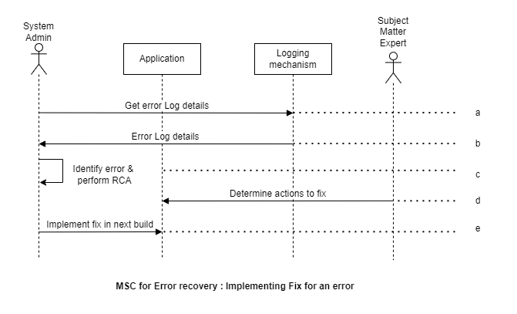

**Figure 3.9.3 Implementing fix to an error**

The above figure 3.9.3 represents the scenario of implementing the fix to an error.

1. After receiving the notification, Sysadmin can obtain the more details of the error from the logging mechanism.
2. When sysadmin requests for error log details, logging mechanism provides the error log details.
3. Sysadmin will analyse the logs and identify the error by performing RCA (Root Cause Analysis)
4. With the help of SME, Sysadmin will the determine the actions that need to be done to overcome the error.
5. Sysadmin will implement the actions that are determined to implement the fix.

## D-G < Application Performance >

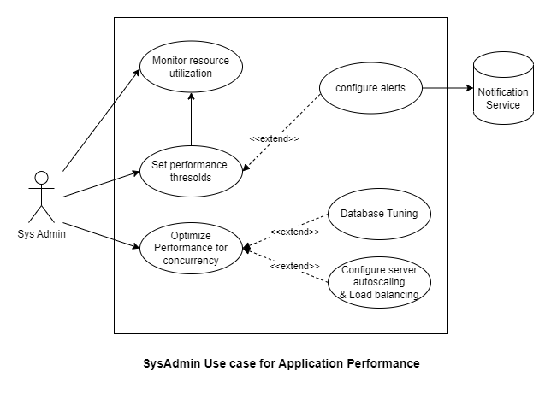

**Figure 3.10.1 Application performance**

* The above figure 3.10.1 represents the use case for maintaining application performance
* This use case covers ***Performance*** requirements.
* In this use case sysadmin will be monitoring the resource utilization of the resources like compute services and databases.
* All the resources are monitored and set with thresholds and if something is being utilized more than expected, alerts can be configured.
* If there are any kind of issues with the performance of the application, sysadmin can optimize the performance for more concurrent users.
* There optimization of the application performance can include different techniques like tuning the database for handling more connections, and load balancing and autoscaling of the application for handling more users.

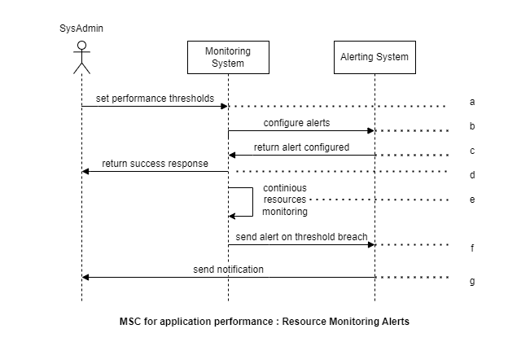

**Figure 3.10.2 Resources monitoring and alerting**

The above figure 3.10.2 represents the scenario of monitoring the resources and configuring the alerts.

1. Based on the requirements, sysadmin will configure the thresholds to the monitoring system.
2. The monitoring system will configure the alerts to the alerting system based on the thresholds. This included to whom an email or an SMS need to be sent.
3. The alerting system will give a success response after the alert is configured.
4. Monitoring system returns the success response to the user will the message of thresholds are configured correctly.
5. The monitoring system will be continuously monitoring the resources and looks for the threshold rules.
6. If any of the resources are being over utilized beyond the maximum thresholds, the monitoring system will send an alert to the alerting system.
7. Alerting system will send the notification to the sysadmin with Email or an SMS.

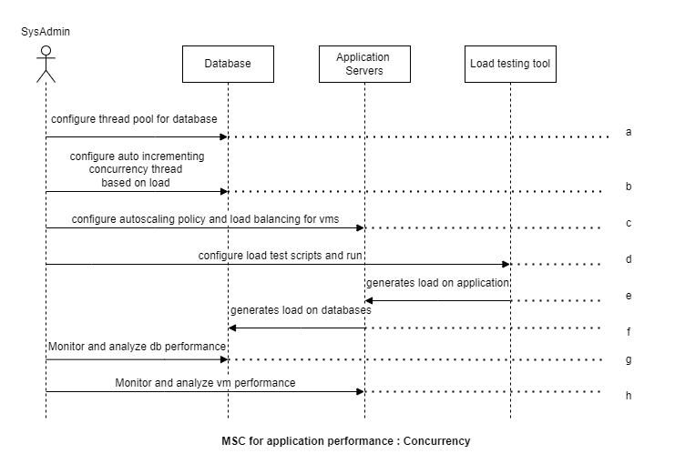

**Figure 3.10.3 Concurrency for application performance**

The above figure 3.10.3 represents the scenario of maintaining the concurrency of the application for better performance.

1. In order to achieve concurrency, sysadmin will configure thread pool for database, which will have established connections.
2. The sysadmin will configure the database that adjusts the number of threads based on the load on the database.
3. Sysadmin will set the autoscaling policies and load balancing which automatically scales the application and scales down when there is no traffic.
4. In order to test the dynamic concurrency, sysadmin will create a load testing scripts in the load testing tool.
5. The load testing tool simulates huge amount of traffic on the application.
6. When there is more load on the application, the application load also imposes the load on the database.
7. The sysadmin will be monitoring the database and analyses the performance and auto adjustments of the thread count.
8. The sysadmin will be monitoring and analysing the autoscaling and load balancing of the resources during high amount of traffic.

## D-G < Reliability and Availability >

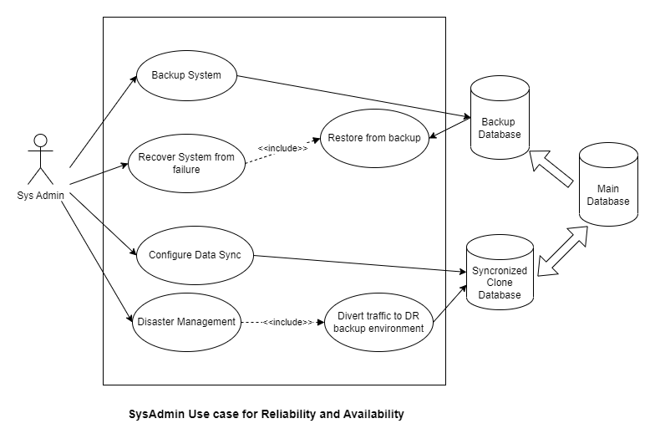

**Figure 3.11.1** **Reliability and Availability**

* The above figure 3.11.1 represents the use case for reliability and availability of the application.
* This use case covers ***Reliability and Availability*** requirements.
* The system needs to be back upped regularly. Sysadmin will also configure the data sync. This will synchronize the data from main database to the cloned database.
* In case of any disaster, the traffic can be diverted to the DR environment which points to the cloned database.
* In case of any failure, sysadmin can recover the system from failure by restoring it from the backup database.

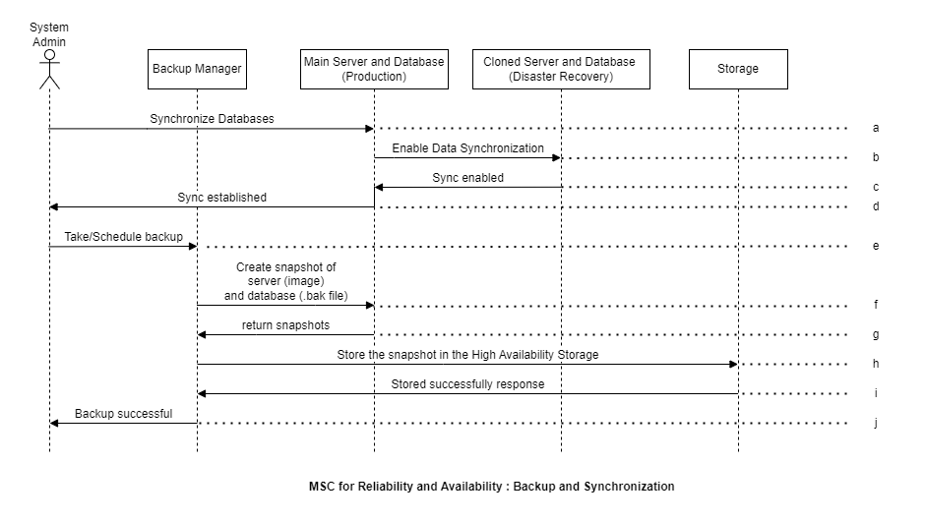

**Figure 3.11.2 Data, Server backup and synchronization**

The above figure 3.11.2 represents the scenario of taking backups of the system and configuring data synchronization for cloned system.

1. Sysadmin will configure the main server and databases to enable synchronization with the cloned system.
2. The main server and databases will establish the synchronization with Change Data Capture methodology.
3. The cloned system will respond back with the success status of enabling the synchronization.
4. The main system will send the success message to the user with the confirmation of synchronization is enabled.
5. Sysadmin can interact with the backup manager to take the backup or schedule the backup.
6. When requested for a backup, backup manager will take the snapshot of the running application server and the database.
7. The snapshots of the server and database will be with the backup manager.
8. In order to make it highly available, these snapshots are versioned and stored in highly available storage.
9. The storage responds back to the backup manager that the snapshots are stored successfully.
10. The backup manager will return the success message to the user stating that the backup is successful.

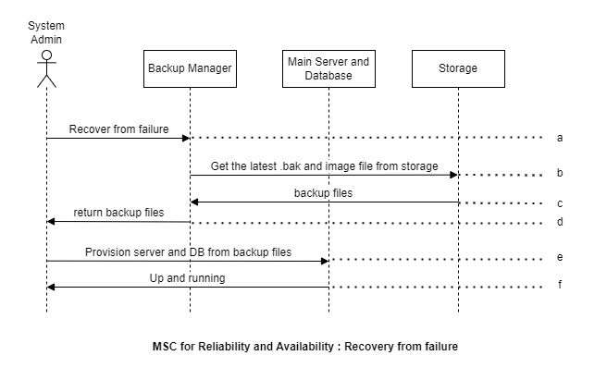

**Figure 3.11.3 Recovery from failure**

The above figure 3.11.3 represents the scenario of recovering the system from failure.

1. In case of failure the system admin will ask the backup manager to get the latest snapshots.
2. Backup manager will retrieve the snapshots of the databases and application servers from the highly available storage.
3. All these snapshots will be returned to the backup manager.
4. Sysadmin will obtain these backup files from the backup manager.
5. Now from the backup snapshots, Sysadmin will provision the application servers and the databases.
6. Sysadmin will verify that the application is up and running and functionally normally after recovering from the failure.

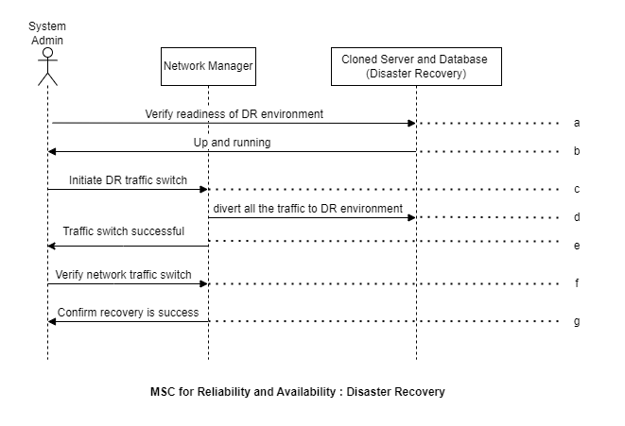

**Figure 3.11.4 Disaster Recovery**

The above figure 3.11.4 represents the scenario of keeping the application up and running in case of disaster.

1. In case of disaster recovery, sysadmin will verify the readiness of the cloned server and database in the disaster recovery environment.
2. The cloned system, will respond to the sysadmins request and the application will be up and running in the disaster recovery environment.
3. Sysadmin will initiate the network manager to switch all the incoming traffic to the cloned disaster recovery environment.
4. The network manager will switch the traffic to the cloned application servers and databases.
5. The network manager will display a message that the traffic was routed to DR environment.
6. Sysadmin will verify that the traffic switch was happened and the traffic is routed to the DR environment by accessing the application.
7. After accessing the application, sysadmin will confirm that the recovery of the application from the failure is successful.

# Enumerated DiagnoGenie Requirements

## Core Requirements

***<DG-Core- 010>***

**The diagnostic lab software application shall provide register and login functionality for different types of users such as patients, doctors, lab technicians, etc.**

***<end of DG-Core- 010>***

***<DG-Core- 020>***

**The diagnostic lab software application shall allow users to schedule appointments and book tests with the lab.**

***<end of DG-Core- 020>***

***<DG-Core- 030>***

**The diagnostic lab software application shall allow users to view their test reports online.**

***<end of DG-Core- 030>***

***<DG-Core- 040>***

**The diagnostic lab software application shall provide real-time notifications and updates to users regarding their test status and results.**

***<end of DG-Core- 040>***

***<DG-Core- 050>***

**The diagnostic lab software application shall keep track of the lab inventory including test kits, reagents, and supplies.**

***<end of DG-Core- 050>***

***<DG-Core- 060>***

**The diagnostic lab software application shall support different types of users such as patients, doctors, lab technicians, etc. and provide them with appropriate access and permissions based on their roles.**

***<end of DG-Core- 060>***

***<DG-Core- 070>***

**The diagnostic lab software application shall comply with DISHA ACT and implement appropriate security measures to protect user data and maintain data confidentiality.**

***<end of DG-Core- 070>***

***<DG-Core- 080>***

**The diagnostic lab software application shall integrate with third-party systems such as payment, notification gateways, and billing systems.**

***<end of DG-Core- 080>***

***<DG-Core- 090>***

**The diagnostic lab software application shall be capable of interacting with hardware devices like QR Code printer/scanner and DICOM printers.**

***<end of DG-Core- 090>***

## Functional Requirements

### User Management

***<DG-User- 010>User Management***

**The DG system shall be capable of managing users with various roles, including administrators, receptionists, lab assistants, lab technicians, supervisors, doctors, and patients.**

***<end of DG-User- 010>***

***<DG-User- 020>User Registration***

**The system shall offer a user registration functionality to register the patients and add the details to the database.**

The database is managed by relational database manager.

Source: MySQL software

Version: 8.0.32

***<end of DG-User- 020>***

***<DG-User- 021>User Registration - Hashing***

**The system shall implement hashing technique while storing the user credentials into the database.**

The hashing technique is implemented using SHA 256 algorithm.

Source: Bouncy Castle library

Version: 1.7

***<end of DG-User- 021>***

***<DG-User- 022> User Registration – User Interface***

**The web registration form shall collect relevant patient information such as name, date of birth, contact details and send it to the server.**

***<end of DG-User- 022>***

***<DG-User- 030>User Roles***

**The system shall define different user roles, such as Administrator, Receptionist, Doctor, Lab assistant, Lab technician, Supervisor, and Patient.**

***<end of DG-User- 030>***

***<DG-User- 040>User Account Creation***

**The Administrator shall have the ability to create new user accounts for Receptionist, Lab Technician, Lab Assistant, Supervisor, and Doctor roles.**

***<end of DG-User- 040>***

***<DG-User- 050>User Authentication***

**The system shall provide a robust user authentication mechanism, such as a username and password combination, to verify the identity of users before granting access to the system.**

***<end of DG-User- 050>***

***<DG-User- 051>User Authentication – Password Expiration***

**The system shall provide a mechanism to verify the expired password and redirect to reset password page.**

***<end of DG-User- 051>***

***<DG-User- 052>User Authentication – Suspended Accounts***

**The system shall provide a mechanism to verify whether the account is suspended or not.**

***<end of DG-User- 052>***

***<DG-User- 060>User Actions***

**The system shall provide granular user permissions to control access to different parts of the system.**

For instance, receptionists will have only permissions to manage patient appointments, while Doctors will have permissions only to view his patient medical records.

***<end of DG-User- 060>***

***<DG-User- 070>Session Token creation***

**The system shall create a session token after authentication, which shall include the session data for continuing the session.**

***<end of DG-User- 070>***

***<DG-User- 071>Session Token deletion***

**The system shall delete the session token from the client and server side when the user logouts from the system.**

***<end of DG-User- 071>***

***<DG-User- 080> Error Handling***

**The system shall display appropriate error message during the registrations and login mechanisms.**

***<end of DG-User- 080>***

### Booking a test

***<DG-Booking- 010>Online Booking***

**The system shall allow patients to browse the tests and book a test online.**

***<end of DG-Booking- 010>***

***<DG-Booking- 020>Walk-In Registration***

**The receptionist shall be able to register a patient who walks in to the laboratory by collecting their details.**

***<end of DG-Booking- 020>***

***<DG-Booking- 021>Walk-In Booking***

**The receptionist shall be able to browse the tests and schedule and appointment for a patient who walks in to the laboratory.**

***<end of DG-Booking- 021>***

***<DG-Booking- 030>Inventory Availability Check***

**The system shall verify in the background whether all the required equipment for the selected test is available in the inventory or not.**

***<end of DG-Booking- 030>***

***<DG-Booking- 031> Inventory – Not available***

**The system shall display the error message to patient or receptionist, if the required equipment is not available in the inventory.**

***<end of DG-Booking- 031>***

***<DG-Booking- 040>Payment Gateway Integration***

**The system shall provide a secure interface for the patient who is booking online to enter their payment details and schedule appointment.**

The online payments are handled by the payment gateways

Source: Razorpay Payment gateway API

Version: 2.3.0

***<end of DG-Booking- 040>***

***<DG-Booking- 041>Payment Gateway - Response***

**The system shall receive the payment status from the payment gateway with HTTPS protocol.**

***<end of DG-Booking- 041>***

***<DG-Booking- 050>Payment Terminal Integration***

**For walk-in test bookings, the receptionist shall initiate payment, for a patient to swipe their card at the payment terminal.**

***<end of DG-Booking- 050>***

***<DG-Booking- 051>Payment Terminal - Response***

**The system shall communicate with the payment terminal using NDC protocol to verify the payment status.**

The communication with the payment terminals is done with NDC protocol using NDC client library

Source: NDC Client library

Version: 0.1.3

***<end of DG-Booking- 051>***

***<DG-Booking- 060>Booking Details Encryption***

**The system shall encrypt the booking details with AES 256 algorithm to maintain privacy of the user information.**

The encryption technique is implemented using AES 256 algorithm.

Source: Bouncy Castle library

Version: 1.7

***<end of DG-Booking- 060>***

***<DG-Booking- 070>Notification API Integration***

**The system shall notify the user about the booking confirmation through Email and SMS using the notification gateway.**

The notifications are sent to the user by the external notification APIs

Source: Msg91 API

Version: v5

***<end of DG-Booking- 070>***

***<DG-Booking- 080>Invoice printing***

**The system shall be able communicate with the printer for printing the invoice.**

The system can communicate with the printer using IPP protocol.

Source: react-native-ipp library

Version: 2.0.0

***<end of DG-Booking- 080>***

### Sample Collection

***<DG-Sample- 010>Fetch Booking Details***

**The system shall retrieve the patient and test booking details and patient contact details from the database.**

***<end of DG-Sample- 010>***

***<DG-Sample- 011>Fetch Booking Details - Decryption***

**The test booking details shall be decrypted using AES 256 algorithm and displayed to the Lab Assistant.**

***<end of DG-Sample- 011>***

***<DG-Sample- 020>Inventory Management***

**The Lab Assistant shall be able to update the inventory after taking the required equipment for sample collection.**

***<end of DG-Sample- 020>***

***<DG-Sample- 030>Sample Collection - Update***

**The Lab Assistant shall be able to update the test collection status in the system once the sample is collected.**

***<end of DG-Sample- 030>***

***<DG-Sample- 040>Status Notification***

**The system shall send a notification through Email/SMS to the patient using notification gateway once the sample is collected successfully.**

The notifications are sent to the user by the external notification APIs

Source: Msg91 API

Version: v5

***<end of DG-Sample- 040>***

***<DG-Sample- 050>QR Code Generation***

**The system shall generate a QR code for each sample collected which contains patient information.**

The QR codes encodes the patient information into them using Zebra Crossing library.

Source: Zxing (Zebra Crossing) library

Version: 3.5.1

***<end of DG-Sample- 050>***

***<DG-Sample- 060>Printing***

**The system shall be able to communicate with the QR code printer using IPP (Internet Printing Protocol) protocol.**

The system can communicate with the printer using IPP protocol.

Source: react-native-ipp library

Version: 2.0.0

***<end of DG-Sample- 060>***

### Performing Test

***<DG-Testing- 010>Updating inventory***

**After receiving test samples, the Lab technician shall update the inventory for the equipment collected.**

***<end of DG-Testing- 010>***

***<DG-Testing- 020>Updating Status***

**The lab technician shall update the status after the test is performed.**

***<end of DG-Testing- 020>***

***<DG-Testing- 021>Status notification***

**The system shall notify the patient after status is updated in the database.**

The notifications are sent to the user by the external notification APIs

Source: Msg91 API

Version: v5

***<end of DG-Testing- 021>***

***<DG-Testing- 030>QR Code Scanning***

**The system shall use a QR code scanner with a camera to scan the QR code and obtain the patient information.**

***<end of DG-Testing- 030>***

***<DG-Testing- 40>Patient information retrieval***

**The system shall obtain patient information from the scanned QR code using ZXing library.**

The QR codes encodes the patient information into them using Zebra Crossing library.

Source: Zxing (Zebra Crossing) library

Version: 3.5.1

***<end of DG-Testing- 040>***

***<DG-Testing- 041>Patient Information - UI***

**The system shall display the retrieved patient information from the scanned QR code.**

***<end of DG-Testing- 041>***

### Reporting System

***<DG-Testing- 010> Report generation***

**The system shall allow Lab technician to generate report using the patient information and the test results obtained from the Lab Workstations.**

***<end of DG-Testing- 010>***

***<DG-Testing- 011>Encryption***

**The system shall encrypt the generated report data using AES 256 algorithm.**

The encryption technique is implemented using AES 256 algorithm.

Source: Bouncy Castle library

Version: 1.7

***<end of DG-Testing- 011>***

***<DG-Reports- 020>Report Printing***

**The system shall allow Lab Technicians to print the X-Rays, MRIs.**

The X-ray type files are in the DICOM format and uses DICOM protocol to communicate with printer.

Source: ngx-dicom library

Version: 1.0.1

***<end of DG-Reports- 020>***

***<DG-Reports- 030> Reports***

**The system shall display reports only to the lab technician, corresponding doctor and patient.**

***<end of DG-Reports- 030>***

***<DG-Reports- 040> Report Decryption***

**The system shall decrypt the reports using AES 256 algorithm.**

The decryption technique is implemented using AES 256 algorithm.

Source: Bouncy Castle library

Version: 1.7

***<end of DG-Reports- 040>***

***<DG-Reports- 050> Report Viewing – File formats***

**The system shall support different file formats like image, video and DICOM for displaying the reports to the user.**

***<end of DG-Reports- 050>***

***<DG-Reports- 051> Report Viewing – DICOM files***

**The system shall display DICOM format report files on the web browser.**

DICOM format report files can be displayed on the browser using dicom-web-viewer.

Source: ngx-dicom-web-viewer library

Version: 0.0.4

***<end of DG-Reports- 051>***

***<DG-Reports- 052> Report Viewing – PDF files***

**The system shall display PDF format report files on the web browser.**

PDF format report files can be displayed on the browser using pdf viewer.

Source: pdf-viewer library

Version: 9.1.4

***<end of DG-Reports- 052>***

***<DG-Reports- 060>Email Report***

**Patients shall be able to email their reports through the system to their registered email using notification gateway.**

The notifications are sent to the user by the external notification APIs

Source: Msg91 API

Version: v5

***<end of DG-Reports- 060>***

### Inventory Manager

***<DG-Inventory- 010>User Access***

**The system shall allow only Lab Supervisor to manage the inventory.**

***<end of DG-Inventory- 010>***

***<DG-Inventory- 020>Inventory Item Addition***

**The system shall have the capability to add new items to the inventory database with relevant details such as name, description, quantity.**

***<end of DG-Inventory- 020>***

***<DG-Inventory- 030>Inventory Updating***

**The system shall have the capability to update the inventory when the equipment was collected for sample collection or testing.**

***<end of DG-Inventory- 030>***

***<DG-Inventory- 040>Threshold Setting***

**The system shall allow the supervisor to set the thresholds for monitoring low stock levels for items in the inventory database.**

***<end of DG-Inventory- 040>***

***<DG-Inventory- 050>Low Stock Monitoring***

**The system shall monitor the stock levels of all items in the inventory database and compare them against the set thresholds.**

***<end of DG-Inventory- 050>***

***<DG-Inventory- 060>Notification***

**The system shall notify the supervisor of the low stock level through a notification sent to their registered email or mobile number using notification gateway.**

The notifications are sent to the user by the external notification APIs

Source: Msg91 API

Version: v5

***<end of DG-Inventory- 060>***

***<DG-Inventory- 070>Inventory Reports***

**The system shall allow the supervisor to generate reports as PDF on the inventory database.**

Result from the database can be converted to pdf using pdf box library.

Source: PDF Box library

Version: 3.0.0-RC1

***<end of DG-Inventory- 070>***

***<DG-Inventory- 080>Inventory Reports - Email***

**The system shall allow the supervisor to send generated reports to his email.**

The notifications are sent to the user by the external notification APIs

Source: Msg91 API

Version: v5

***<end of DG-Inventory- 080>***

## Error Recovery

***<DG-Error-010>Logging Mechanism***

**The system shall have a logging mechanism to log all events in the application, ensuring traceability and accountability of the system.**

The system can use logging library to add warning levels to the logs.

Source: Logging library Sl4j

Version: 2.0.6

***<end of DG-Error-010>***

***<DG-Error-020>Error Logging***

**The system shall log error information to the logging mechanism, ensuring that errors are recorded and can be reviewed.**

All the application logs from servers can be sent to central logging database like Elasticsearch.

Source: Elasticsearch

Version: 7.14

***<end of DG-Error-020>***

***<DG-Error-030>Error Detection***

**The system shall detect errors when they are logged to the logging engine, ensuring timely resolution of errors.**

***<end of DG-Error-030>***

***<DG-Error-040>Error Notification***

**The logging system shall send a notification to the administrator through the email.**

The notifications are sent to the user by the external notification APIs

Source: Msg91 API

Version: v5

***<end of DG-Error-040>***

***<DG-Error-050>Error Analysis***

**The sysadmin shall be able to analyze errors from the logging mechanism, identifying the root cause of the error.**

**<end of DG-Error-050>**

***<DG-Error-060>Root Cause Analysis***

**The sysadmin shall be able to perform root cause analysis to identify the underlying cause of the error, ensuring effective resolution of errors.**

The root cause analysis can be performed by going through the hierarchy of the error log generated.

Source: Kibana

Version: 7.14

***<end of DG-Error-060>***

***<DG-Error-070>Error Resolution***

**The sysadmin shall determine the action to fix the error with the help of Subject Matter Experts (SMEs), ensuring effective resolution of errors.**

***<end of DG-Error-070>***

***<DG-Error-080>System Recovery***

**The sysadmin shall recover the system from the error by implementing the fix, ensuring that the system is fully functional and available for use.**

***<end of DG-Error-080>***

## Operations, Administration and Maintenance

***<DG-OAM-010>Access Control Management***

**The system shall allow the administrator to give access control to the users of the system like doctors, lab technicians, assistants and receptionists.**

***<end of DG-OAM-010>***

***<DG-OAM-020>Access Control Management***

**The system shall allow the administrator to manage the access control matrix by defining actions for each role, specifying who can do what.**

***<end of DG-OAM-020>***

***<DG-OAM-030>Data Export and Anonymization***

**The system shall allow the administrator to export data by deidentifying and anonymizing it, ensuring the privacy and confidentiality of the data.**

***<end of DG-OAM-030>***

***<DG-OAM-040>Encryption Key Management***

**The system shall allow the administrator to rotate the encryption keys, ensuring the security and integrity of the data.**

***<end of DG-OAM-040>***

***<DG-OAM-050>Re-encrypting data***

**The system shall decrypt old data and encrypt the data with new encrypted keys using AES-256.**

The encryption and decryption technique is implemented using AES 256 algorithm.

Source: Bouncy Castle library

Version: 1.7

***<end of DG-OAM-050>***

***<DG-OAM-060>Password Policy Management***

**The sysadmin shall be able to change the password policy based on the requirements, ensuring the security and confidentiality of the data.**

***<end of DG-OAM-060>***

## Performance

***<DG-Perf-010> Monitoring System Resources***

**The system shall be capable of monitoring the system resources, such as CPU usage, memory usage, and disk space.**

All the resources like virtual machines and databases can be monitored by running monitoring agents that sends data to monitoring tool Prometheus.

Source: Prometheus

Version: 2.43

***<end of DG- Perf -010>***

***<DG- Perf -020> Setting Alert Thresholds***

**The system shall allow administrator to set the thresholds for alerting to the monitoring system, specifying the acceptable range of values for each monitored metric.**

***<end of DG- Perf -020>***

***<DG- Perf -030> Alert Notifications***

**The monitoring system shall notify the administrator via email, SMS, if any threshold is breached, providing relevant details such as the name of the metric, the value, and the time of the breach.**

***<end of DG- Perf -030>***

***<DG- Perf -040> Database Concurrency***

**The administrator shall configure to auto increase the concurrency of the database connections based on the load on the database.**

***<end of DG- Perf -040>***

***<DG- Perf -050> Load Balancing and Autoscaling***

**The sysadmin shall configure a load balancer and auto scaling policies to the servers for scaling the system based on traffic.**

***<end of DG- Perf -050>***

***<DG- Perf -060> Performance Testing***

**The administrator shall generate load scripts to test the autoscaling of the application and analyze the performance.**

The load testing tool JMeter is used to stimulate traffic by writing test scripts.

Source: Apache JMeter

Version: 5.5

***<end of DG- Perf -060>***

## Security

***<DG-Security-010>Strong Password Policy***

**The system shall enforce a strong password policy that requires users to create a secure password and regularly change it.**

***<end of DG-Security-010>***

***<DG-Security-020>Authorization***

**The system shall perform authorization for all the actions by verifying the user role with Access Control Matrix.**

***<end of DG-Security-020>***

***<DG-Security-030>Data Encryption and Hashing***

**The system shall encrypt and decrypt all the user data at rest with AES 256 algorithm and the password should be securely hashed with SHA256 algorithm.**

***<end of DG-Security-030>***

***<DG-Security-040>Asymmetric Encryption***

**The system shall possess asymmetric encryption with private and public keys for encrypting the data at motion.**

***<end of DG-Security-040>***

***<DG-Security-050>Idle Timeout***

**The system shall automatically logout the user if the idle time is more than 5 minutes.**

***<end of DG-Security-050>***

***<DG-Security-060>Session Management***

**The system shall delete the session token on the client side after user logging out.**

***<end of DG-Security-060>***

***<DG-Security-070>Data Packet Validation***

**The system shall be able to validate the checksum of the incoming data packets using CA certified SSL certificates.**

***<end of DG-Security-070>***

***<DG-Security-080>Request Denial***

**The system shall deny the request if the checksum in the header and checksum of data is not matching and this should be logged for further analysis.**

***<end of DG-Security-080>***

***<DG-Security-090>Account Suspension***

**The system shall suspend the user account for malicious activity.**

***<end of DG-Security-090>***

## Availability and Reliability

***<DG-A-R-010> Synchronization Configuration***

**The sysadmin shall configure synchronization between the main application server, database, and cloned application server and database, for disaster recovery purpose using CDC (Change Data Capture).**

***<end of DG-A-R -010>***

***<DG-A-R -020> Backups***

**The sysadmin shall take scheduled backups of the database and the application server running in the production.**

***<end of DG-A-R -020>***

***<DG-A-R -030> Storage Management***

**The sysadmin shall store the backup snapshots in a highly available storage.**

***<end of DG-A-R -030>***

***<DG-A-R -040> Notification Alert***

**The system shall send an alert via SMS or email alert to the administrator if the application is down.**

The notifications are sent to the user by the external notification APIs

Source: Msg91 API

Version: v5

***<end of DG-A-R -040>***

***<DG-A-R -050> Recovery from failure***

**The administrator shall be able to provision the application server and database and restoring it from the last available backup snapshots.**

***<end of DG-A-R -050>***

***<DG-A-R -060> Disaster Recovery***

**The administrator shall redirect all traffic to the DR (disaster recovery) environment in case of a disaster, maintain business continuity.**

***<end of DG-A-R -060>***

# Open Issues

1. Integration of the medical equipment in the laboratory with DiagnoGenie. Some medical devices lack in standardized protocols for data exchange between software and them.
2. Staying updated with the regulation changes as per the DISHA Act regulations. It is always important to ensure that our lab's software is secure and complies with relevant data protection laws.

# Decision Log

|  |  |  |
| --- | --- | --- |
| **Date** | **Decision** | **Reason** |
| 01/30/2023 | Initial problem statement | Project Deliverable 1 |
| 02/12/2023 | Problem statement 1.0 | Changes made and updated problem statement |
| 02/13/2023 | Enumerated requirements | Updated from the customer |
| 02/13/2023 | Elicitation plan and result | Project Deliverable 2 |
| 02/23/2023 | Updated with more questions | Corrections made |
| 03/05/2023 | Context diagram | Edited as per the review |
| 03/5/2023 | Use case diagrams | Created the use cases for blastoff |
| 03/23/2023 | Completed blastoff | Updated version for blastoff – Project Deliverable 3 |
| 03/12/2023 | Message Sequence Chart diagrams | Created the MSCs for presentation |
| 03/23/2023 | Updated Software Requirement Specifications | Project Deliverable 4 |
| 04/14/2023 | Finalized Software requirements specification | Rough draft version – Project Deliverable 5 |
| 04/16/2023 | Finalized Software requirements specification | Completed and improvised version – Project Deliverable 5 |

**Table - 4 Decision Log during various stages in the project**

# Future Considerations

* Mobile applications will play an increasingly important role, providing lab managers and staff with real-time access to lab data and results, as well as notifications and alerts. We should consider implementing a mobile application to enhance accessibility and efficiency.
* The future of diagnostic labs will see increased use of automation and artificial intelligence, with AI algorithms being used to analyze test results, automate data entry, and perform quality control checks.
* Predictive analytics, utilizing machine learning and data analysis, will also become more prevalent in diagnostic labs, enabling the prediction of patient outcomes, identification of equipment failures before they occur, and inventory forecasting. Machine learning algorithms will improve the efficiency and accuracy of diagnostic tests, automate tasks like image analysis, and help identify trends and patterns in lab data.

# Acknowledgments

The DG project team would like to acknowledge the contributions of all the reviewers and stakeholders that includes:

**Suresh Pamu** – Customer

**Ram Dharavath** – Doctor

I would like to express my sincere thanks to Hemanth Lella for his invaluable support and guidance throughout this project as a Subject Matter Expert.

We would also like to extend special thanks to our professor, **Dr. Gus Samba** and **Naveena Kanderi**, for their support, review and encouragement throughout the course of the project.